Budget – 1st Payroll of the New School Year

Part 1

Presented by ESC, Region 14

2020

Log into Budget

1. Create a folder for Backups and Reports on your desktop named 2020-2021 Budget- 1st Payroll. When prompted to make a backup, we recommend saving in a subfolder labeled with that step number. This will make it is easy to tell which backup needs to be selected to get back to the point in the process desired should that be needed. In addition, create a subfolder for Budget Simulations and Reports.

2. Update historical data. Since our budget for 2018-2019 may have changed since we last worked in it, we must update the 2018-2019 budget file. This will ensure we have true data for comparison purposes.

From Utilities > Update Budget Data,
- Select File ID 9 – 2018-2019

Retrieve
- Check to update the Amended and Actual columns. Updated information will pull from Finance.
- Move all Funds to the right

Execute.
- Save the backup in the Budget folder in Step 2.

Note: On the left side you will see year 9 and possibly 0. Move all funds to the right.

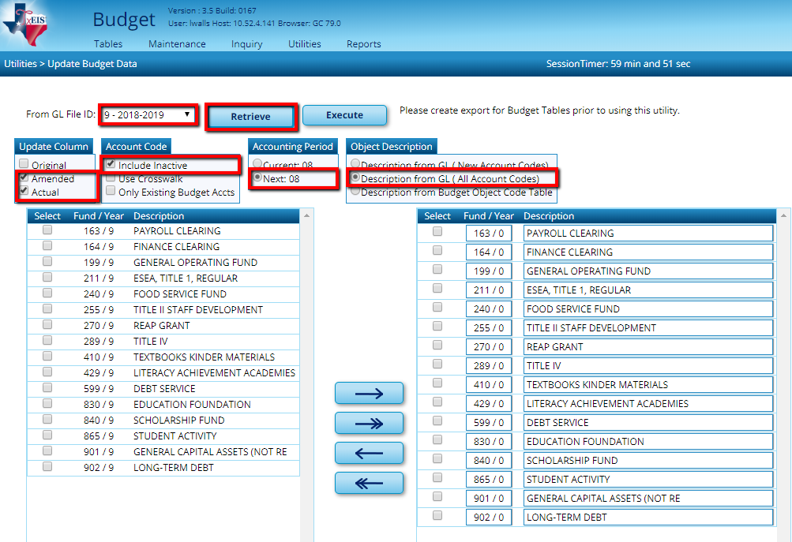
At the Preview, select Process to update all amounts

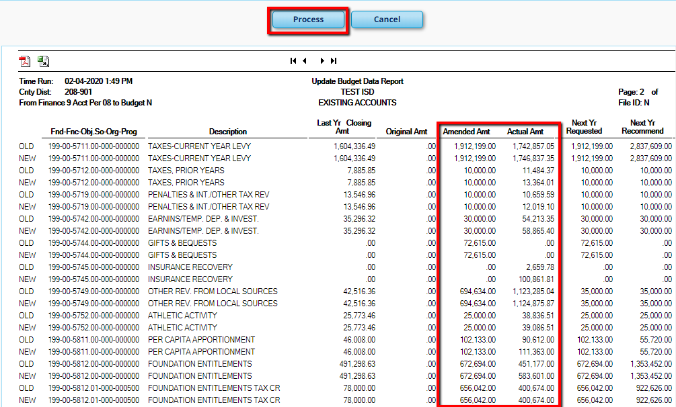

Note: A Budget Error Report will generate if there are account components that exist in the Finance Account Code table, but not in the Budget Account Code table. If you receive a Budget Error Report, you must add the account components listed on the report to Budget. You will not be able to continue successfully without addressing this report.

Example:
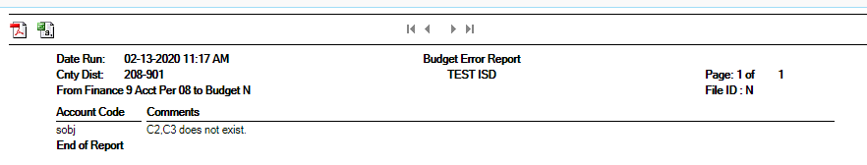

If you wish to review, from Inquiry > Budget Account Codes Inquiry, retrieve a Summary of all Accounts.

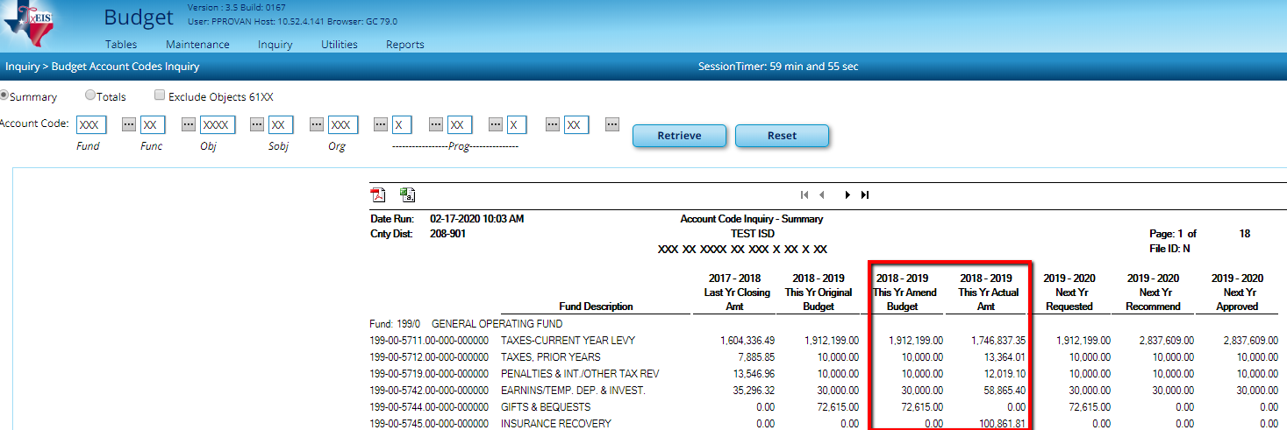

3. Make a backup of File ID 9 and N from Utilities > Export by File ID.

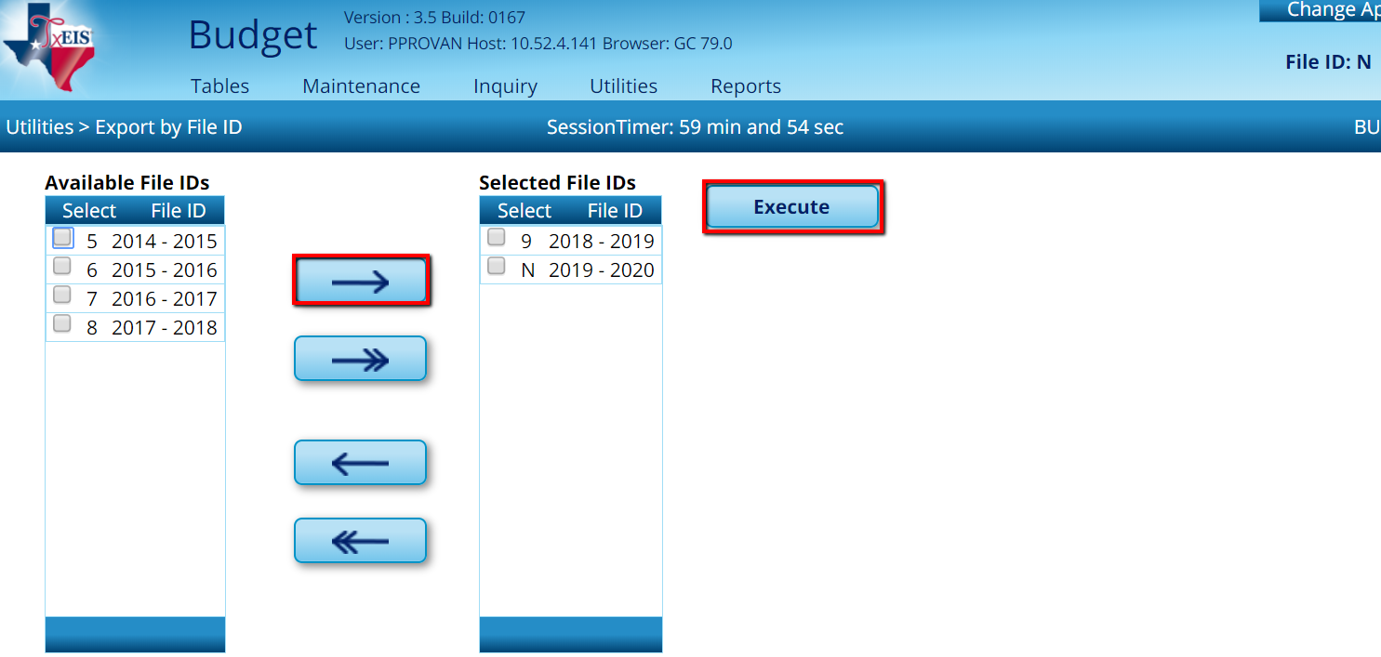

4a. Save 2019-2020 data for historical purposes. If File ID 0 already exists, you must first delete that file ID. You may choose to do an Export by File ID of File ID 0 and save elsewhere for your records, but we typically do not use Budget files that are 10 years old.

- Verify you are in File ID N, and go to

Utilities > Delete by File ID
- Select File ID 0 and pull to the right.
- Execute

Once the old File ID 0 is deleted, you can easily complete step 4b.

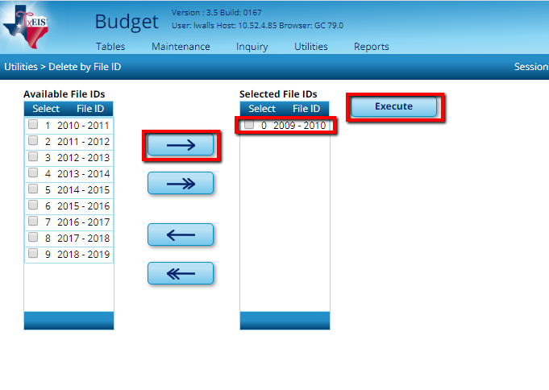

4b. Save 2019-2020 data for historical purposes. From Utilities > Copy Current to New File ID, select 0 as the New File ID and Select All at the bottom of the screen. Execute.

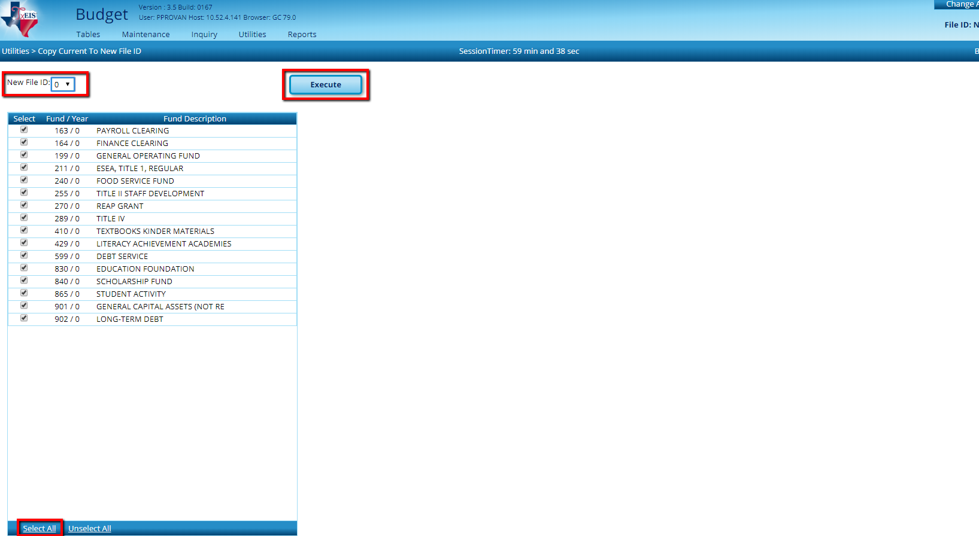

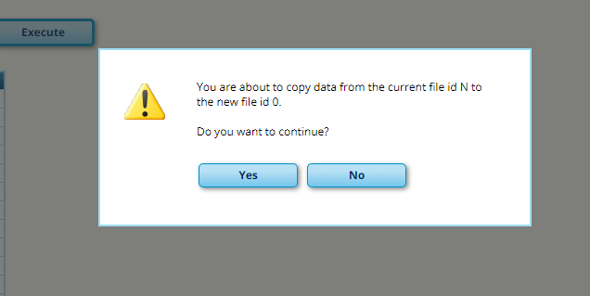

5. Sign into the new File ID 0 and verify the budget data. Use Inquiry to verify account information was copied and/or print the Budget Report by Fund. Compare File ID 0 to File ID N.

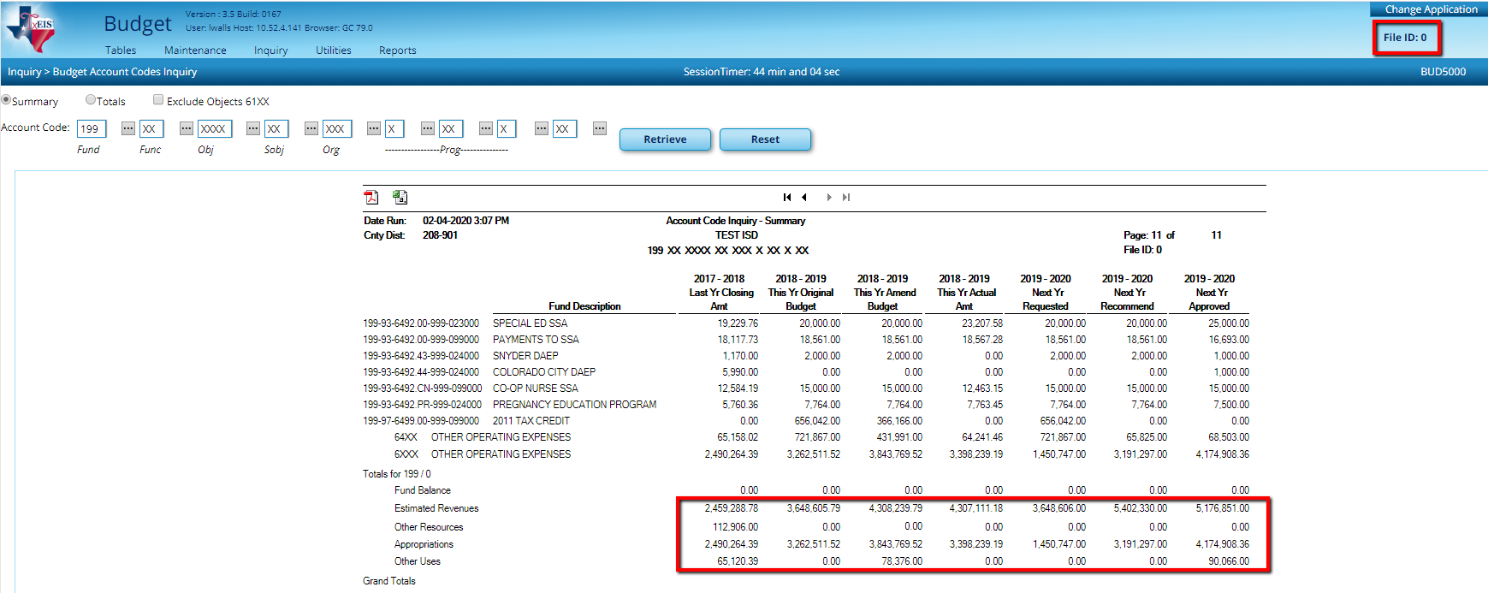

6. Make a backup of File ID 0 from Utilities > Export by File ID.

Sign back into File ID N.

7. Set up File ID N to represent 2020-2021. From Tables > District Budget Options, update the school year and cut-off dates for the new budget year.
- Enter year 2020-2021
- Set cutoff dates for budget tabs as desired
- Verify that the “Capture Original Budget Flag” is checked (This will capture the Approved budget as Original budget when Budget is moved to Finance) and Save.
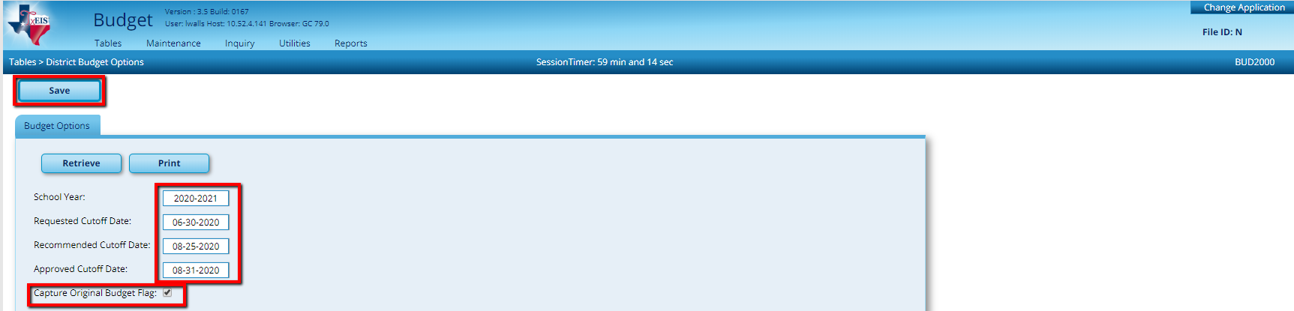

8. Review the Account Code tables in Budget and Finance and delete prior year Fund/FY codes that are no longer used.

In Budget go to Tables > Account Codes and review the Fund/FY tab.

In Finance go to Tables > Account Codes and review the Fund/FY tab.
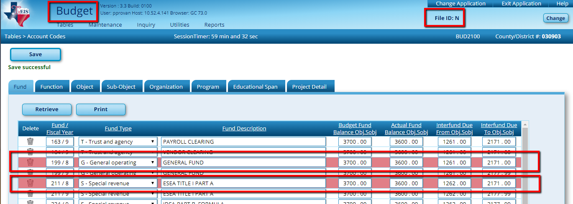
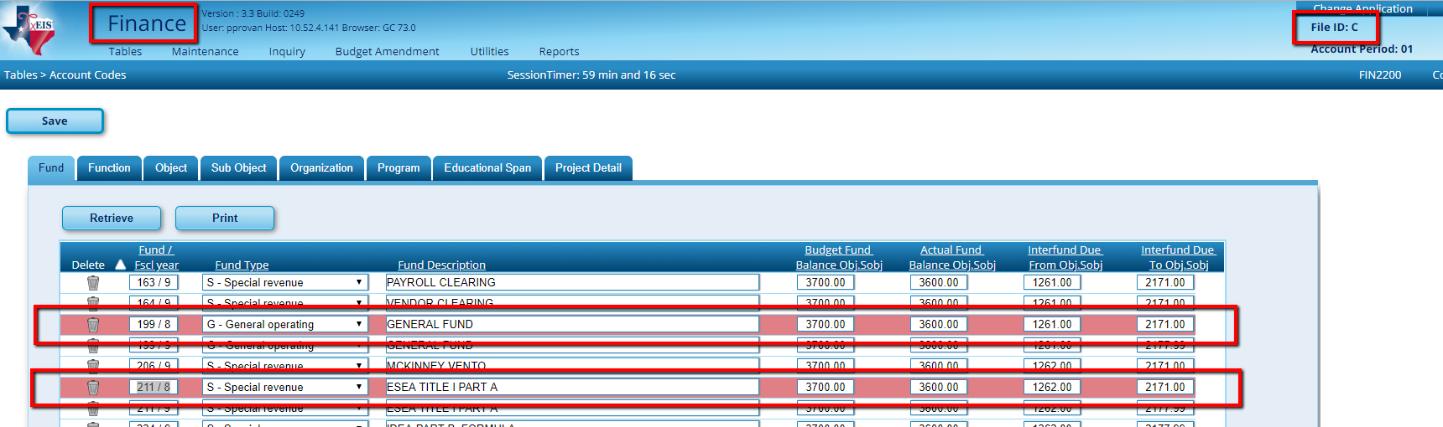

Log back into BUDGET.

(DO NOT DO MORE THAN ONCE!)

9. Reinitialize the budget.
Budget Inquiry includes columns displaying account information for the 2018-2019 and 2019-2020 school years. Seeing data that spans multiple years can be helpful in determining trends and highlighting budgetary considerations.
Information for the 2019-2020 school year includes the amounts originally budgeted, amended budgets (where applicable), and realized revenues/expenditures to date. Information from the prior school year is limited to one column. Districts may choose to see budgeted or actual revenue/expense for comparison, but not both.

Before Reinitializing Budget
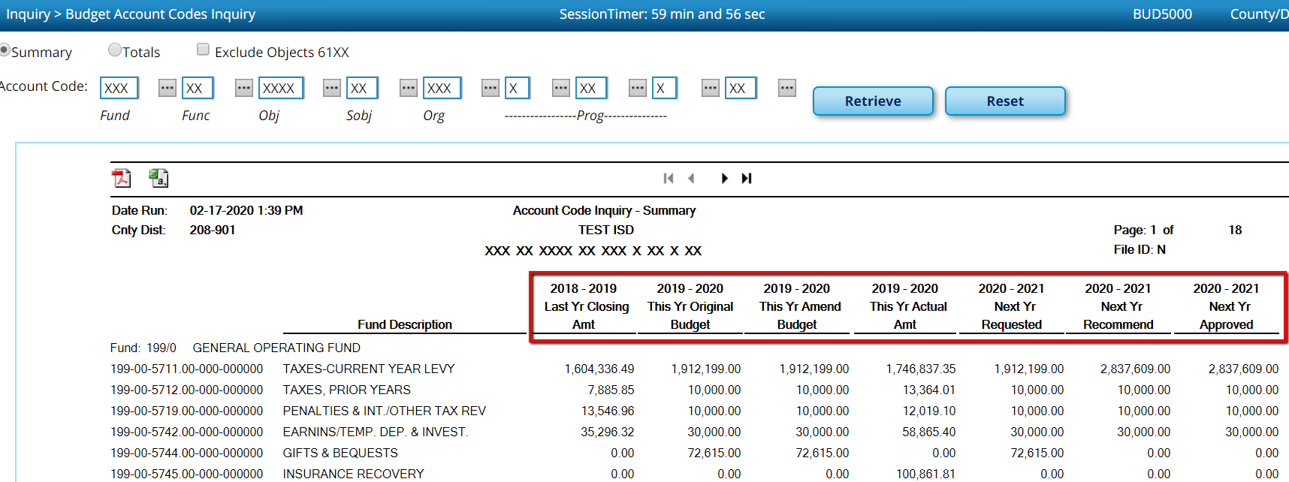

Again, only complete this step ONE TIME!
From BUDGET >Utilities >Reinitialize Budget Data, select whether you want to view 2019-2020 expenditures or amended budget amounts, move all fiscal year 0 funds to the right, and Execute.

This will:
- Place the 2018-2019Amended Budget or Actual Expenditure amounts (as selected) in the Last Year Closing Amt. column.
- Move the 2019-2020 Approved Budget to the This Yr Original Budget column.
- Zero out the Amended, Actual and NY Approved columns so the budget building process can begin for 2020-2021.

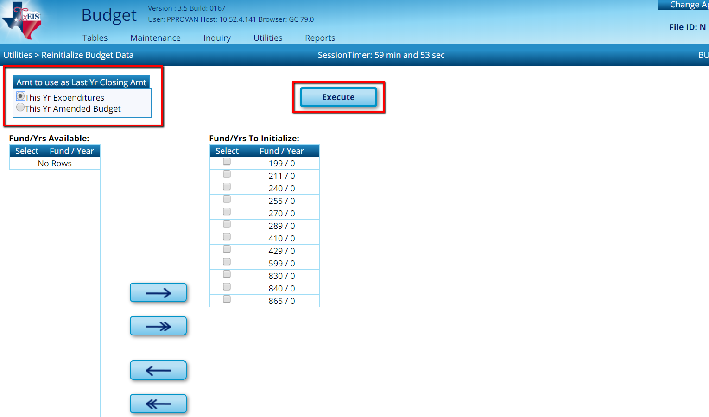

At the Preview select Process.

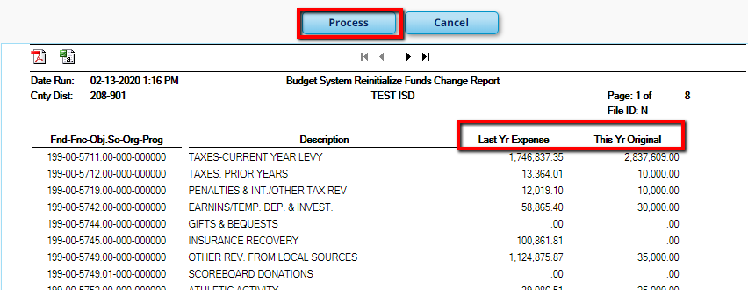

After Reinitialize Budget Data, to view the results, go to Inquiry > Budget Account Codes Inquiry and Retrieve all accounts. The first two columns (2018-2019 Last Yr Closing Amt and 2019-2020 This Yr Original Budget) should show amounts. The other columns will be zeros at this point.

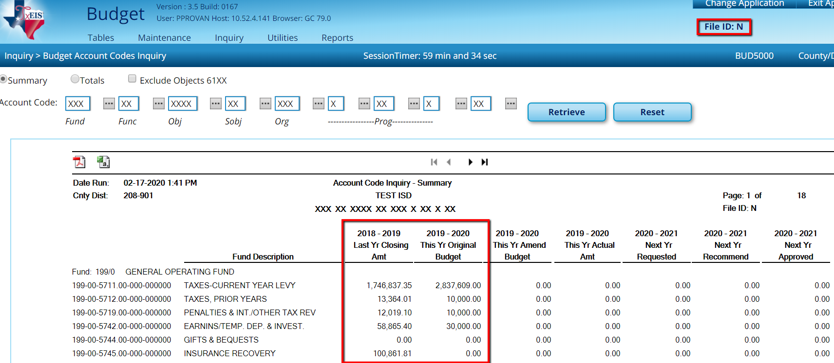

10. Mass change the fiscal year to FY 1 in the Account Code tables. From Utilities > Mass Change Account Codes, move all Fund/FY 0’s to the right and Execute. This feature adds the Fund/FY to the Budget Account Codes table. (This may include funds you won’t be using next year, but you will still need to move all of them to the right for this step. We will delete unwanted funds in a later step.)

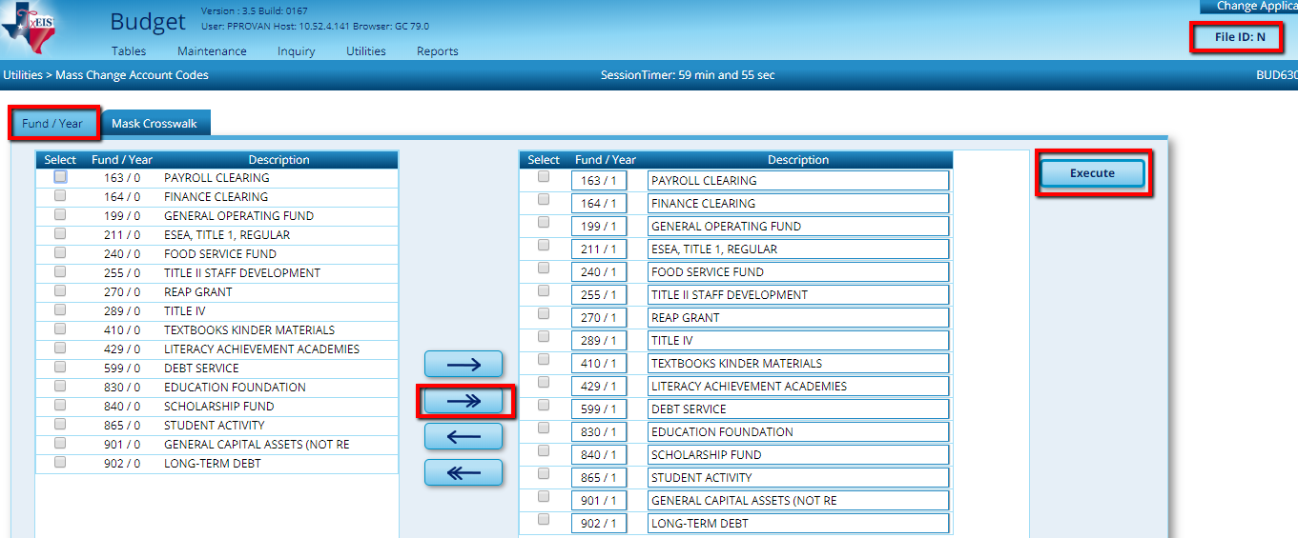

At the Preview select Process.

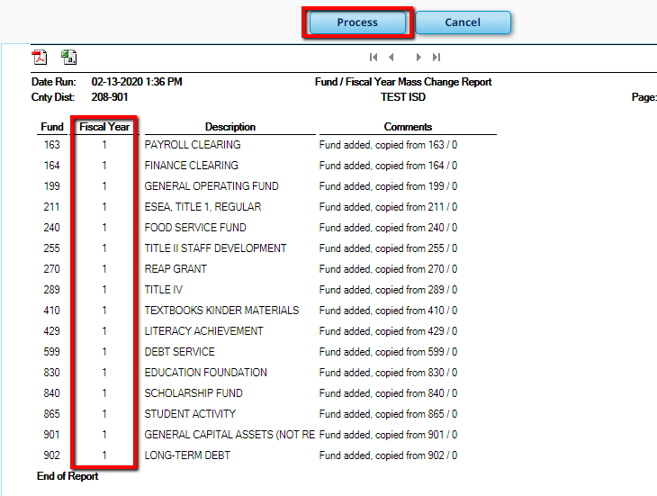

11. Mass change the individual account codes in Budget from fiscal year 0 to fiscal year 1. From Utilities > Mass Change Account Codes > Mask Crosswalk tab, enter a 0 in the Fiscal Year field in the From Mask and a 1 in the To Mask. In the Object Descriptions box, select to use Existing Code Descriptions from Budget. Do not select any Options. Execute.
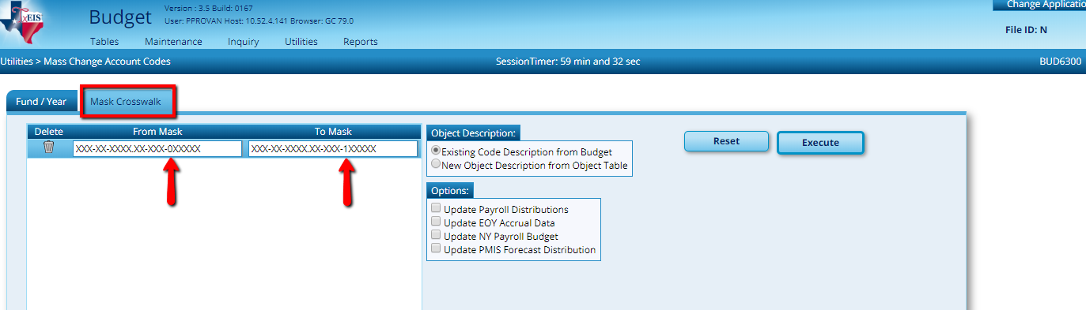

At the Preview, select Process.
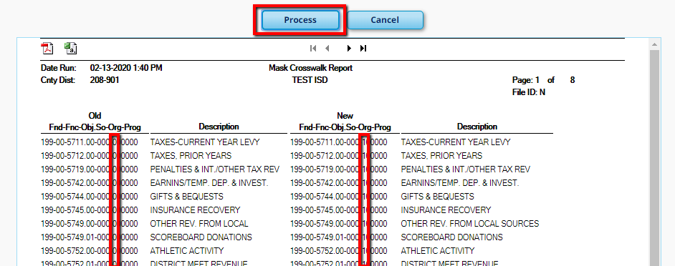

To view the results, go to Inquiry > Budget Account Codes Inquiry and Retrieve all. All accounts should show a fiscal year of 1.

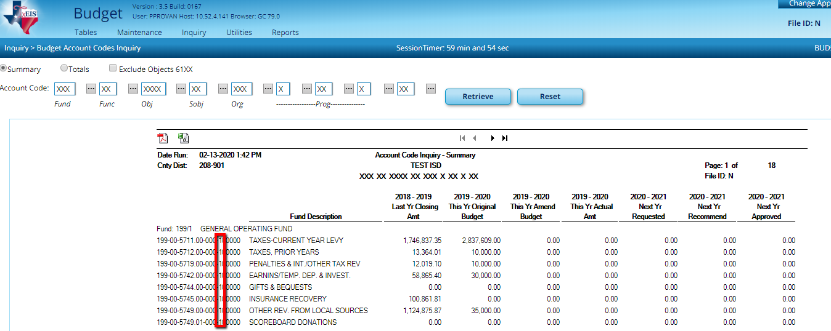

12. Update the Budget Account Code tables in File ID N to reflect the same information that currently exists in Finance File ID C. This will only add Finance tables that do not exist in Budget. From Utilities > Clear/Copy Budget Tables > Copy Finance Tables to Budget tab, move all tables to the right and Execute.
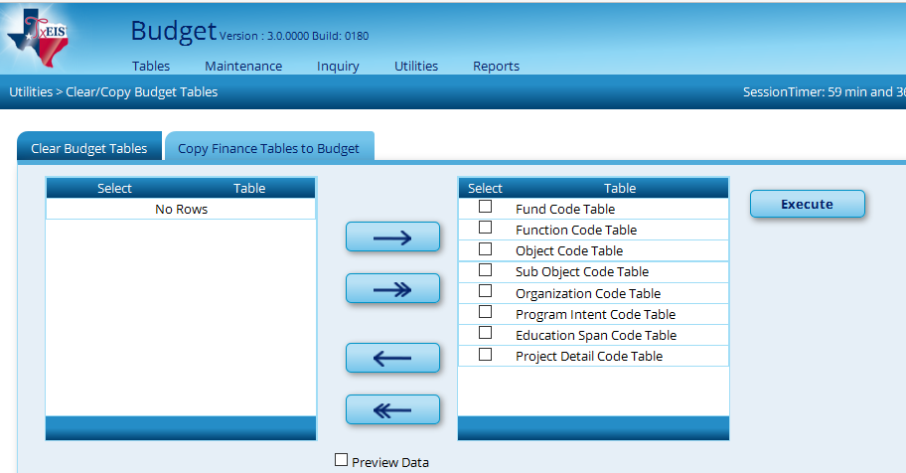

If you use Next Year Requisitions complete step 13.
If not, skip to step 14.
13. Clear any requisitions created in 2019-2020 for the 2020-2021 school year that were not moved to current year from Utilities > Clear/Move NYR Requisitions to CYR. Leaving the PO date as zeros, select Clear NY Requisitions Only and Execute.

Note: Be sure to verify with Finance that no requisitions and/or purchase orders have been created in NY Requisition for the 2020-2021 school year. If this feature is already being used for the 2020-2021 school year, skip this step. Old 2019-2020 requisitions will have to be deleted individually in this instance.
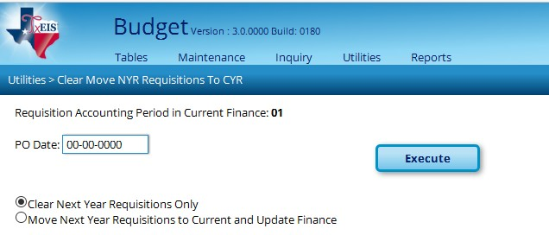

14. Delete any funds that you no longer want to display in file ID N from Utilities > Delete Funds, move desired funds to the right and Execute. This utility deletes all accounts and funds from the following menu selections:

  - Maintenance, Budget Data
    - Requested
    - Recommended
    - Approved
  - Maintenance, Budget Data-Quick Entry
    - Requested
    - Recommended
    - Approved
  - Utilities > Move Budget to Finance
  - Utilities > Reinitialize Budget Data

It will not clear the following tables:

  - Utilities > Create Budget Data (this is read from Finance)
  - Utilities > Update Budget Data (this is read from Finance)
  - Utilities > Update Last Year Closing (this is read from Finance)
  - Utilities > Mass Change Account Codes > Fund Year (this is read from the Account Code table)
  - Utilities > Copy Current to New File ID (this is read from the Account Code Table)

Note: This is just an example and is not suggesting you delete Acct 211

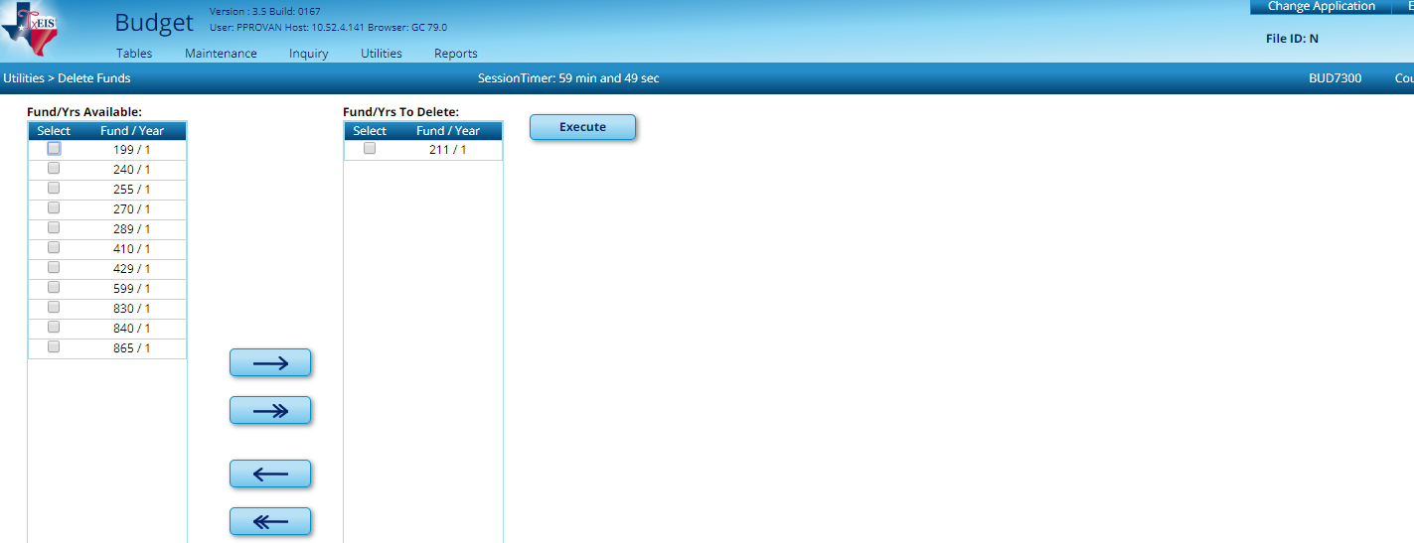

At the Preview, select, Process.
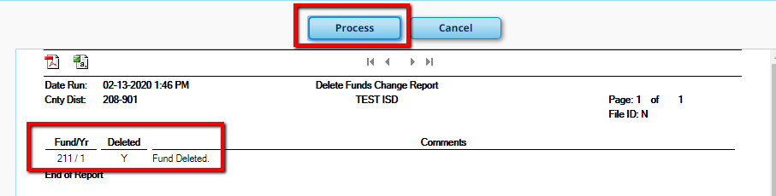

15. If desired, clear the budget tables. From Utilities >Clear/Copy Budget Tables > Clear Budget Tables tab, select both boxes and Execute. This utility only clears the Simulation and/or Crosswalk tables.
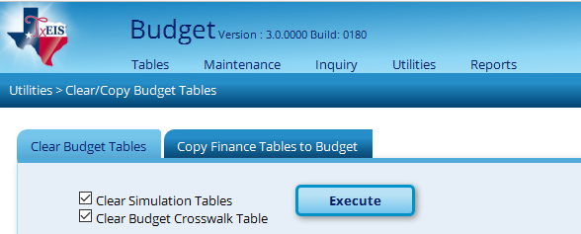

Note: Do not check Clear Simulation Tables if you will be using the same Simulations you used last year. If you are unsure which ones you used last year, go to Reports > Budget Reports > BUD1200 Simulation Report to view your Simulations.

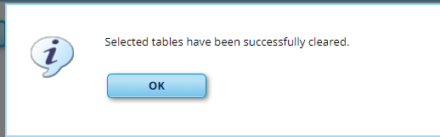

16. Clean up Budget Funds /Fiscal Years you no longer want displayed by deleting them from Tables > Account Codes > Fund tab.

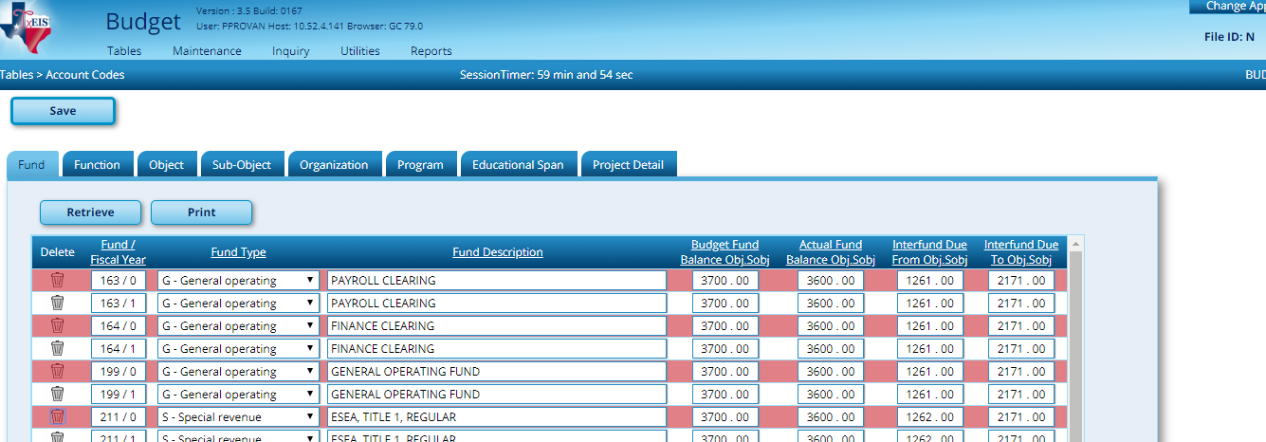

17. Update This Year Amended and/or This Year Actual Columns. You can perform this step many times to update your budget.

From Utilities > Update Budget Data, select the dropdown to pull from GL File ID C, check the boxes to update Amended and/or Actual.

Consider the following:

Account code: Do you want to include only those accounts that have a matching number in Budget, or include all accounts that are in Finance.

Object Description: Choose your preference.

Description from GL (New Account Codes) - will use the account code description from Finance on any new Budget Codes. All other will retain the description currently shown in Budget.
Description from GL (All Account Codes) – will use account code descriptions from Finance for all codes. Be aware that choosing this option means that if you have re-named account codes in Budget, those changes will be lost.

Description from Budget Option Code Table – will use the description from Tables > Account Codes > Object tab for accounts. This will over-ride existing descriptions. Must not use this for the final move.

Move all funds to the right, and then Execute. This utility extracts current data from Finance so you can see more current figures for comparison purposes.

Note: Please create export for Budget Tables.

Perform this utility on an as-needed basis to keep these columns up-to-date.
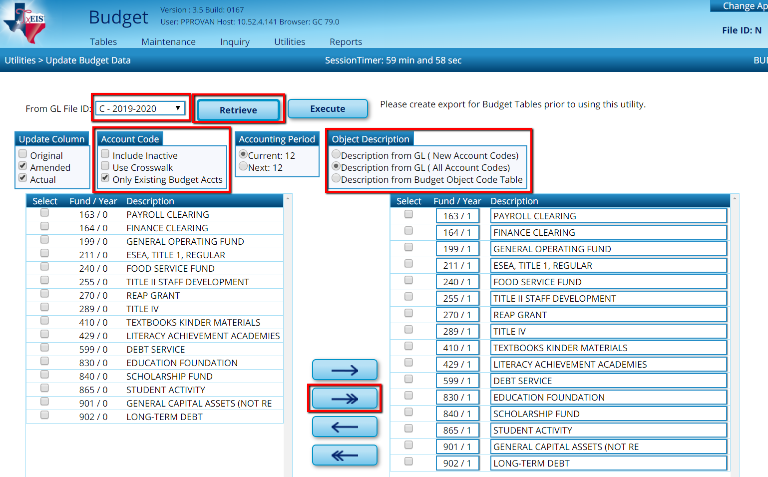

At the Preview, select Process.
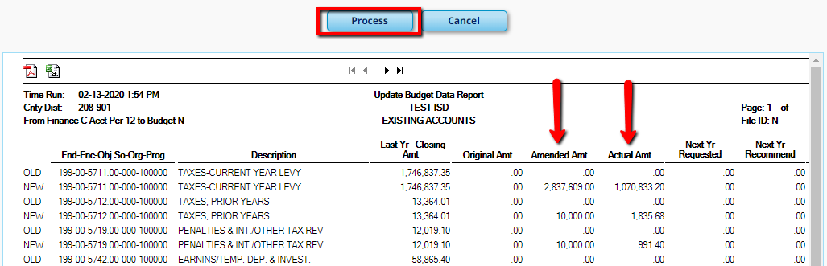
To view the results, go to:
Inquiry > Budget Account Codes Inquiry and Retrieve all. Updated numbers will be displayed in the 2019-2020 This Yr Amended Budget and 2019-2020 This Yr Actual Amt Columns.

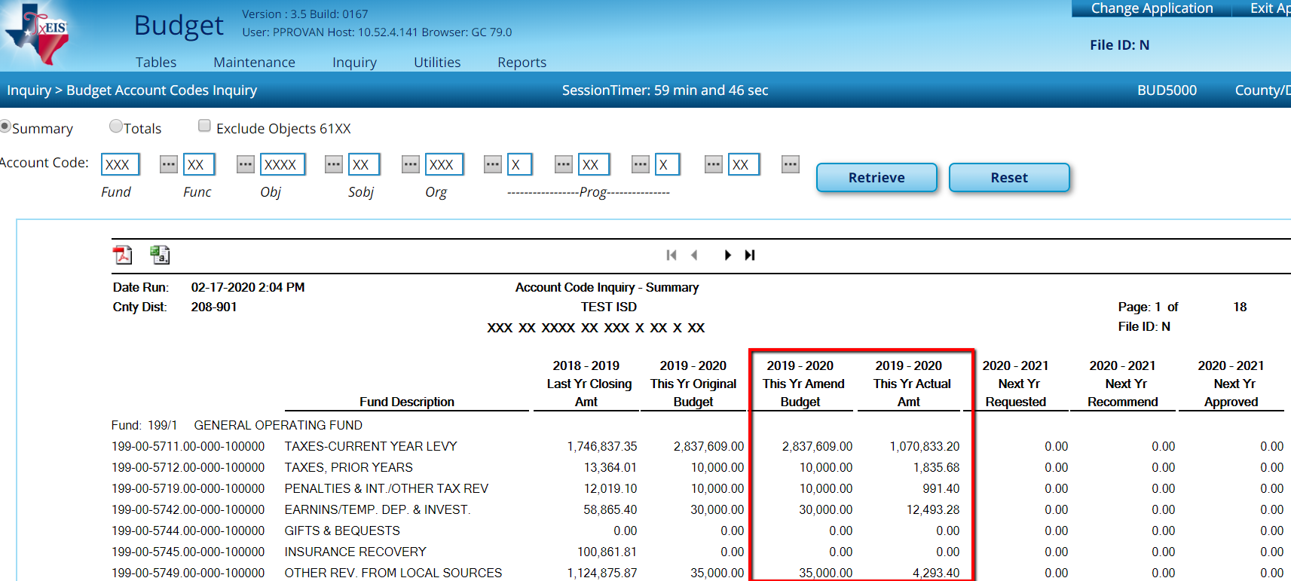

18. Make a backup of File ID N from

Budget > Utilities >Export by File ID.

District Administration

19. If you are using an X in the Fiscal Year field for all user profiles, you can skip this
step. If not, Update User Accounts in District Administration under Utilities > Mass Update User Accounts by Fund.
All funds that have specific fiscal years in User Profile will display. Pull all Funds to the right, select Options on the right to grant access in desired applications, and Execute.

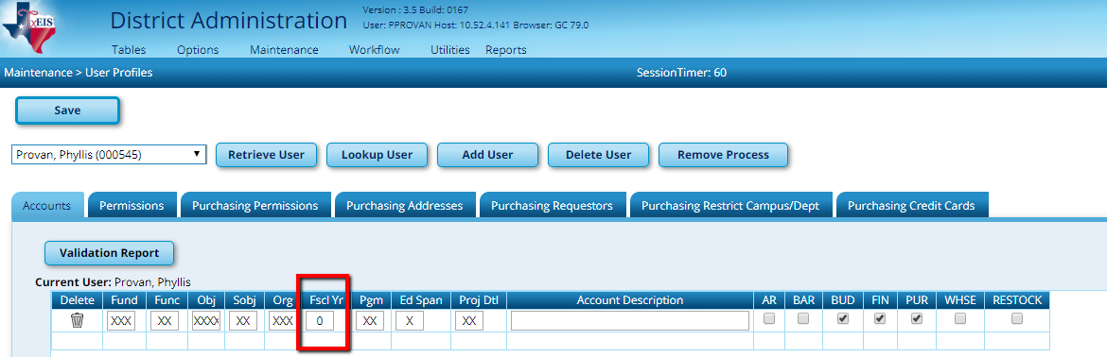

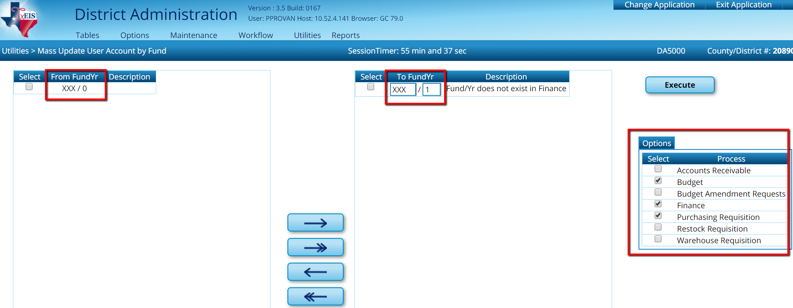

If you are currently using Purchasing and plan to use Next Year Purchasing complete step 20.

If you are not planning on using Next Year Purchasing, skip to step 21.
NY Purchasing allows users to submit and approve Requisitions for the next school year. The Budget process for the new year must be completed to step 22 before NY Purchasing may be utilized.

Caution: We recommend approvers wait to Approve NY requisitions until they are moved to current as NY Requisitions are only validated against the account codes in Budget and NOT the amounts. If approvals are allowed, it is possible for accounts to be overspent.

20. Review and update Purchasing Options as needed from District Administration > Options > Purchasing/Warehouse > Next Year Tab.

While we do not recommend the use of a cutoff date in Current Year Purchasing Options, we do recommend it here. Setting a Cutoff Date will ensure that no one can use NY Requisitions after the new year has begun. Save any changes.
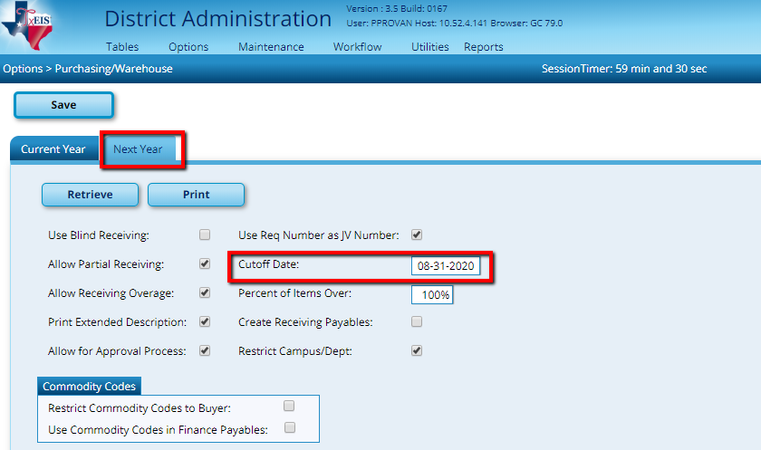

Go back to Budget

File ID N, in Budget, is now ready for 2020-2021 amounts. The amounts can be entered using

one of two methods.

Method A allows starting figures to be populated quickly based on last year’s budgeted amounts or actual expenditures. Initial amounts are populated automatically based on parameters of your choosing and then can be tweaked as needed. If you would like to use Method A, proceed to step 21.

Method B entails entering an amount for each account code by hand. If you would like to use Method B, skip to step 23.

Method A – Auto Population from Simulations

21. Create Budget Simulations from Utilities > Mass Increase/Decrease Account Codes

NOTE: If prior year simulations were not deleted, this step can be skipped. (Step 15)

Determine whether you want to modify the Requested, Recommended or Approved Budget columns and select that tab at the top of the screen.

You can create multiple simulations to review. Each simulation must be Saved AND Executed, before entering the next. (In this step, you are only creating simulations, not actually populating Budget with the amounts. Populating Budget occurs in step 22.) A couple of examples have been provided below for illustration.

Example 1: Simulation to populate the Requested column with the same amounts as

This Year Amended Budget.

    - Enter a Simulation Name (6 characters)

Simulation Description.
    - Select an option from the Base Column. For this simulation, we want the same numbers as “This Yr Amend Budget.”
    - Use the +Add link to add a line. Enter the account code(s) you wish to affect.
    - Because we want the exact same amount as 2019-2020 Amended Budget, we select an Operator of “No Change.”

Save
    - Execute

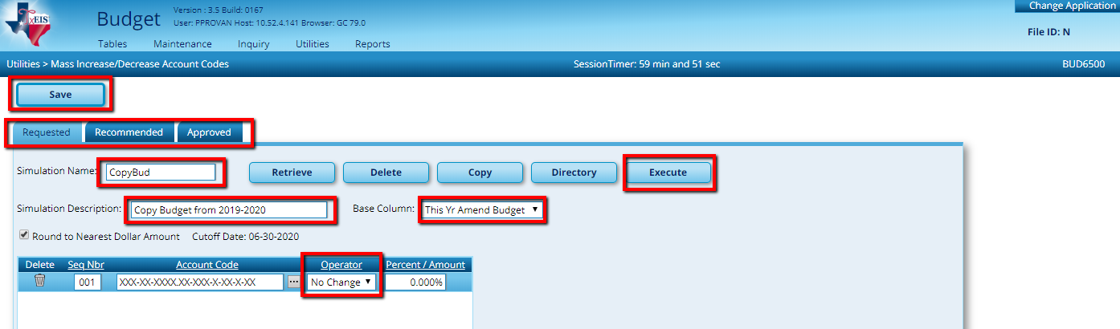
Save, then Execute.

Note: Remember, this will not change on the Budget/Inquiry Screen until you do step 22.

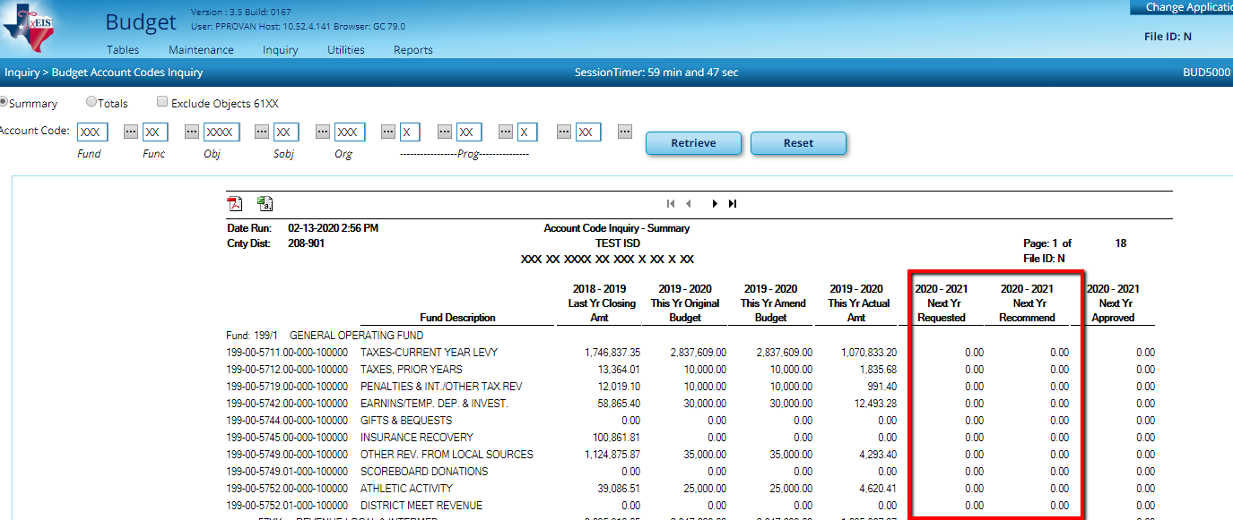

Example 2: Simulation to populate the Recommended column with a 5% increase over This Year Amended Budget.
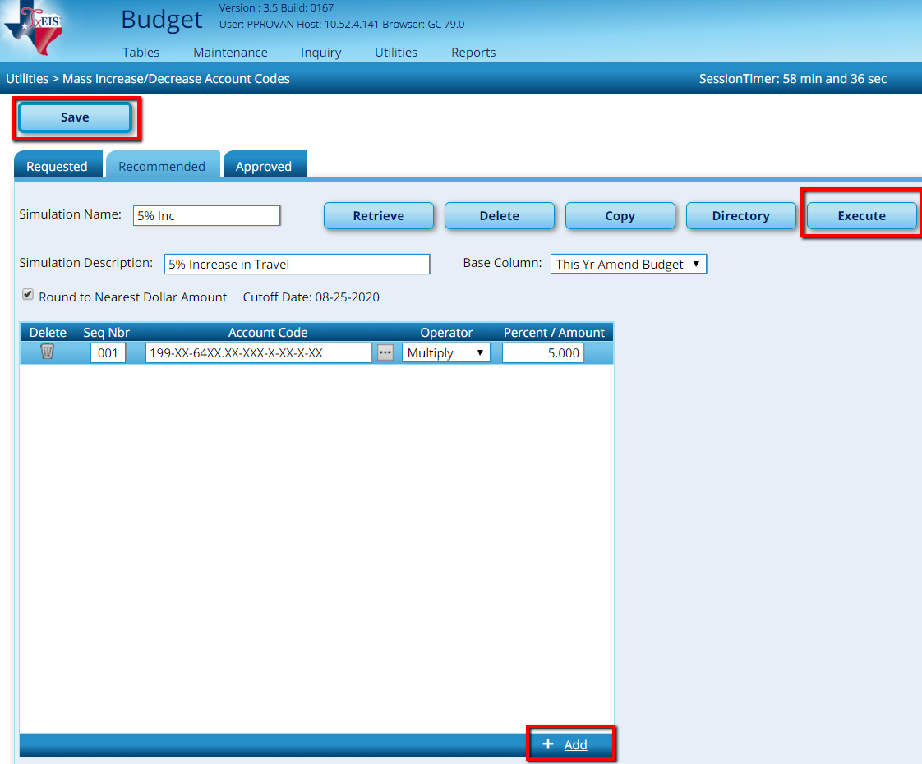

Save first before you Execute
Choose the Column
you want to affect
Last Select Execute

Note: Remember, this will not change on the Budget/Inquiry Screen until you do step 22.

Build additional simulations as desired and review reports to decide which figures you want to use to auto-populate the budget.

Note: Once you have Saved and Executed your Simulation and you want to create a NEW Simulation using a New Name and New Description, you are able to do this by typing over the old simulation that you had saved and executed thus creating a New Simulation.

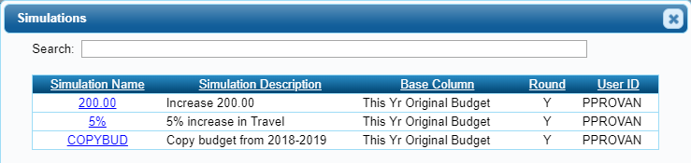

Note: Our examples have built simulations in the Requested & the Recommended tabs. You may also build simulations in the Approved tab as well.

22. Interface desired Budget Simulation. Once you have decided which simulation you wish to use to auto-populate the corresponding column, proceed to

Utilities > Budget Level Processing.

Example: Use the Budget Level Processing utility on the Requested tab to update your budget with the same amounts as 2019-2020 Amended Budget.

On the Requested tab, select the simulation you wish to update the budget with (SAME) and Execute.

At the Preview, select Process.
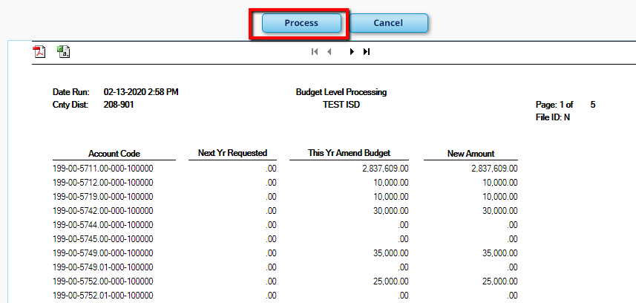

Review the data from Inquiry > Budget Account Codes Inquiry.

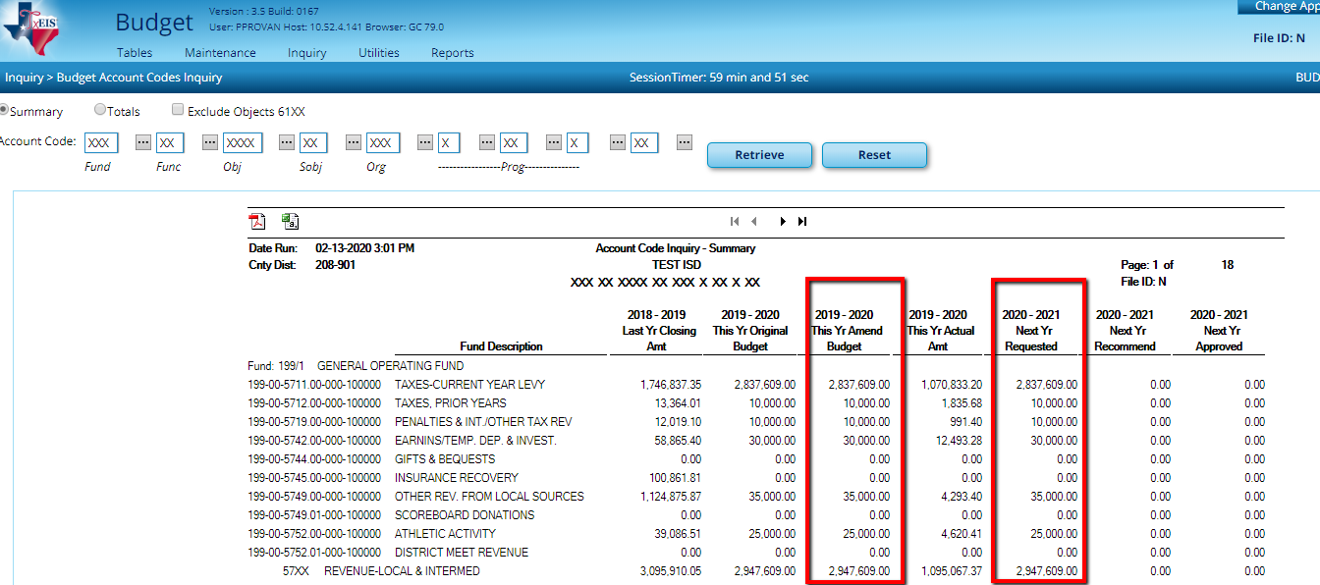

Note 1: This step can be repeated as needed. Each time a simulation is executed, it will overlay the prior simulation with the new information.

Note 2: This example was interfaced in the Requested Column. The same process can be used to create simulations for the Approved or Recommended columns as desired.

If you have chosen to use Method A, step 22 will only be used to adjust budgets. The initial amounts will have been already populated.

Method B – Hand Entry of all budgets
(or continued adjustment of budgets for those using Method A)

23. Enter or adjust Budget information. Determine whether you would like to have the ability to adjust account code fields and amounts or just enter dollar amounts.

- If you choose to open up account code fields for editing, go to Maintenance > Budget Data.
- If you only wish to affect dollar amounts, go to Maintenance > Budget Data – Quick Entry.

Three tabs are available at the top of the screen: Requested, Recommended, and Approved. We recommend you begin on the Requested tab though changes can be made on any of the three.

Budget Data Budget Data Quick Entry
Quickly Enter Amounts and Notes.
Able to change the Account Code, the Amount, the
Description and add Notes.

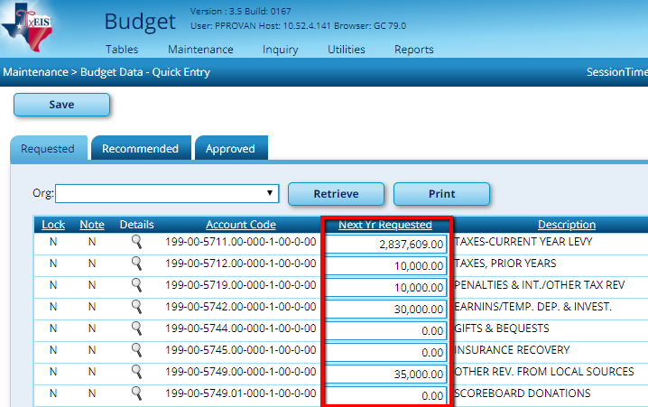
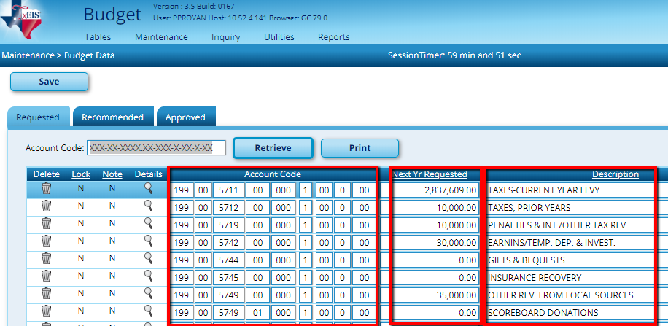

Clicking on the spyglass in front of the account code will open a popup box containing more information on each account code.

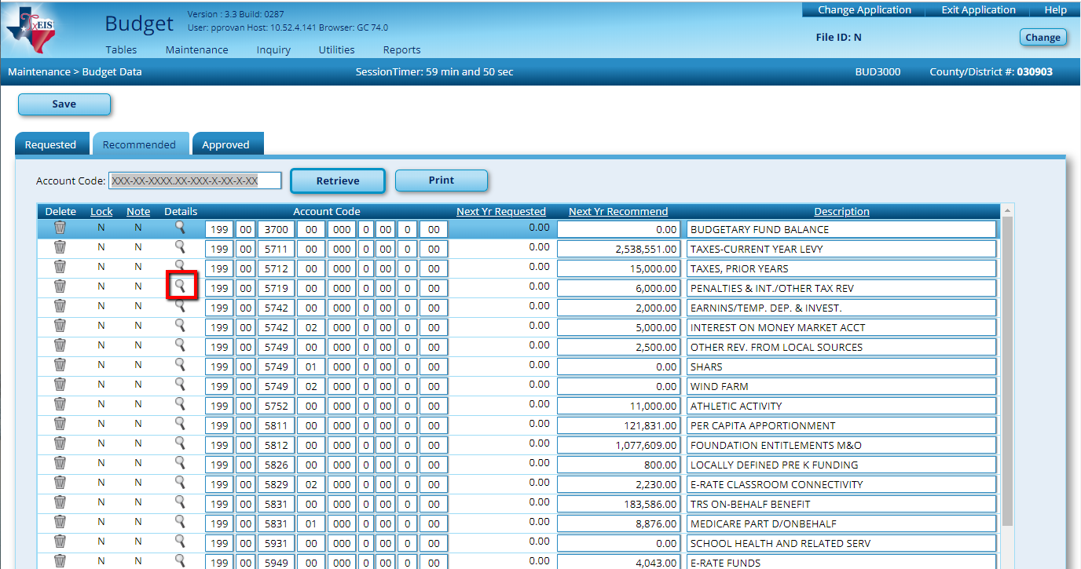
The Pop-up Box on the Budget Data screen changes can be made to the Budgeted Amount and Description, as well as Notes entered from this pop-up.

The Pop-up Box on the Budget Data – Quick Entry screen changes can be made to the
Budgeted Amount and the Notes but not the Description.

The OK button will take you back to the home screen, or you may use the arrows in the bottom right corner to navigate to the next and/or previous account code.

Select the fields you wish to change and enter the data desired. You may enter several changes prior to saving.

Budget Data

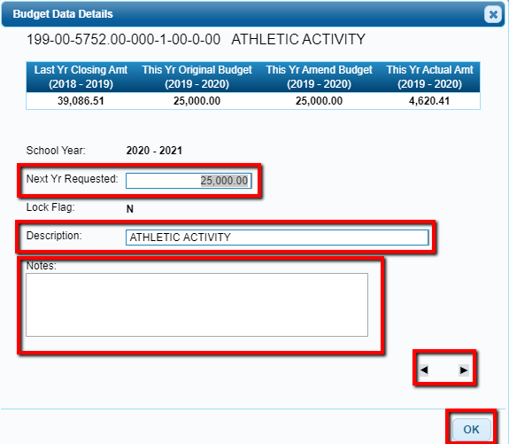
Description field is not displayed if using Budget Data Quick Entry

24. Set up Campus level users and forward their checklist to them. A separate document will walk you through the steps to set those users up.

If users at the campus level work in Budget, refer to the Campus Budget User documents. This is a checklist that can be forwarded to them to help them complete the steps they will do.

You may now begin working in Next Year Payroll.

Log into Human Resources – Current Pay Frequency

To begin HR processing, make a backup by going to Utilities > Export Human Resources by Payroll.

Note: If at any time, there is an error and you need to import a backup go to Utilities > Import Human Resources Tables.

25. Clear the next year tables. In the Current File ID, from Next Year > Copy CYR Tables to NYR > Clear Next Year Tables tab, move all tables to the right and Execute.

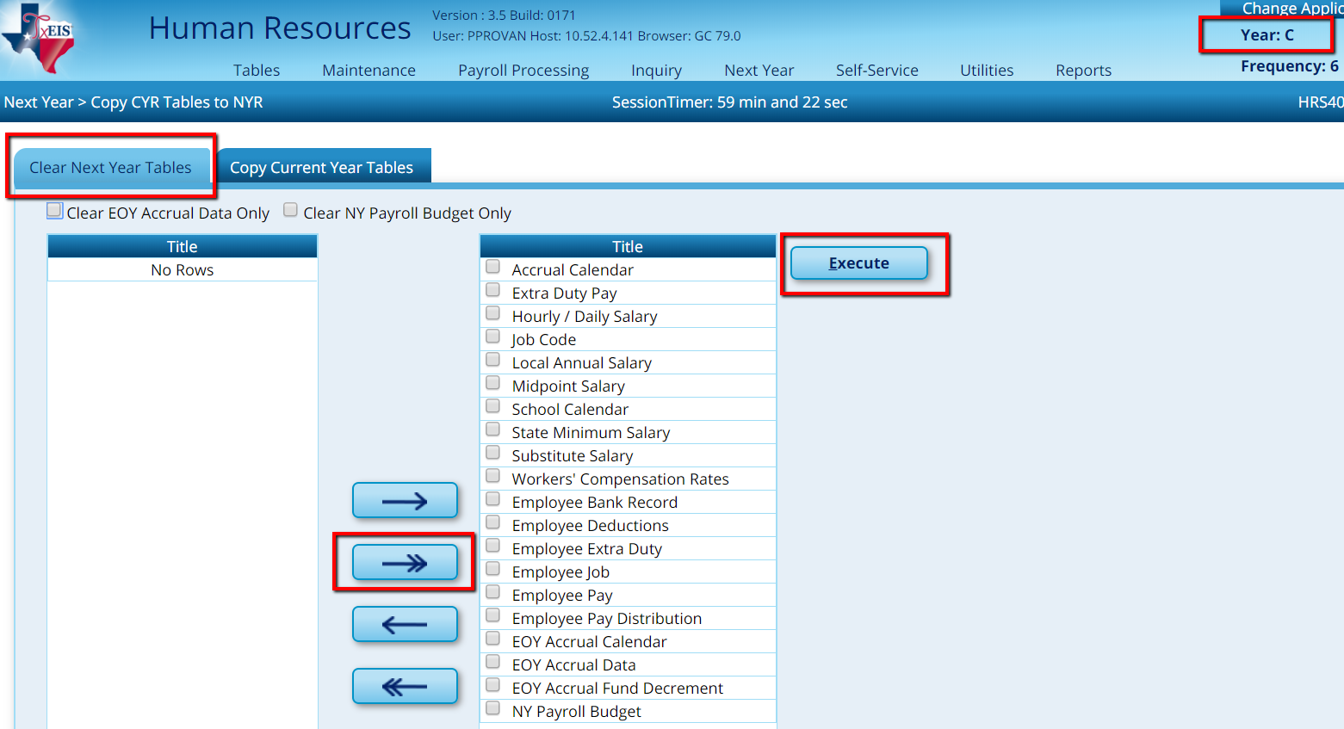
26. Copy Current Year Tables on the second tab. Select All Tables or check them individually by using the box to the right of each table. Execute. All Tables will come up individually for you to review and click Process.

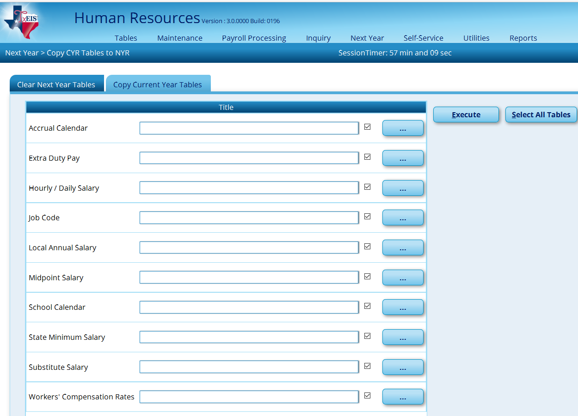

When every Table has been processed you will get a popup showing the Name of the Tables along with the number of rows. Click OK.
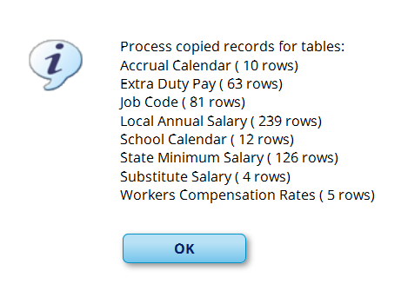

27. CYR Staff to NYR from Next Year > Copy CYR Staff to NYR. Choose the following and then Execute:
  - Active employees (even if you have some employees who are not coming back. This ensures you are budgeting for the position.)
  - Pay Type E (Exclude Substitute.)
  - Pay Frequency. Note: If you have more than one pay frequency, you’ll need to repeat this step for each payroll frequency.
  - Under Options: Select Include Employees with Termination Date
And you have the option to type Next Year’s Funding Code (This feature will allow you to skip the mass update step later on)
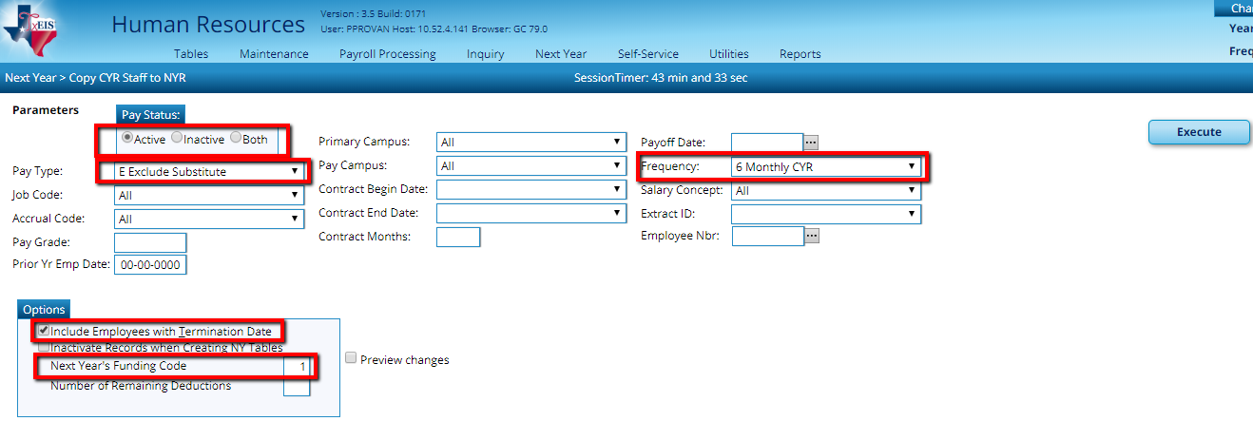

Note: This step will process the Employee Pay, Job, Extra Duty, Pay Distribution, Bank Deposit and their Employee Deductions.

At the preview, select Process.

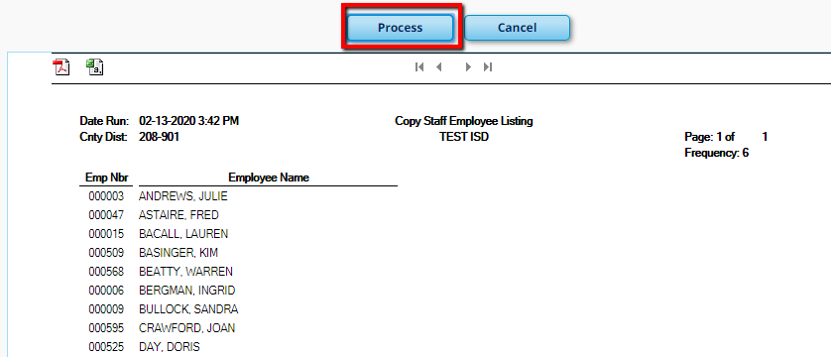

Change to Next Year Pay Frequency

28. Review the District HR Options table. Tables > District HR Options. We recommend Pay Rate, Daily Rate, Accrual Rate, and Overtime Rates are set to automatically compute.

Note: This table is shared between Current and Next Year Payroll so any changes made will affect Current Year Payroll as well.

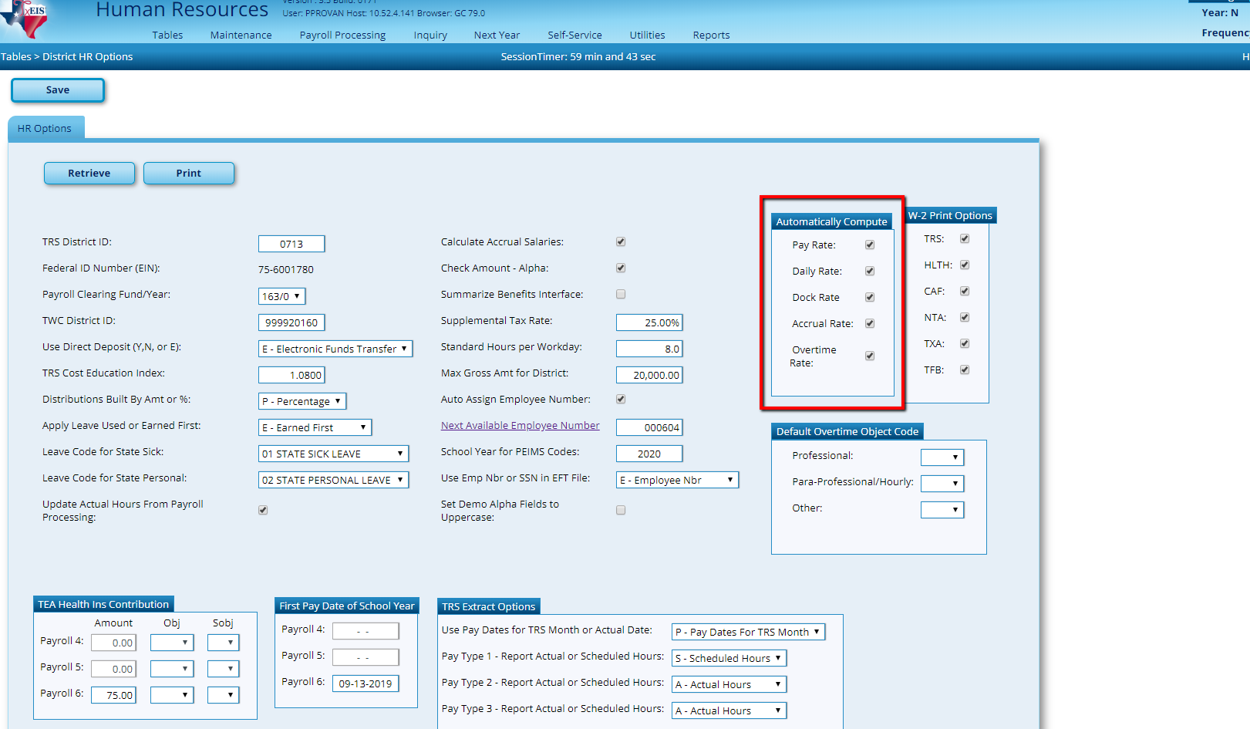
29. Review and update TRS Rates from Tables > Tax/Deductions > TRS Rates. Enter 2021 in the School Year and click Retrieve. A message will pop up asking if you want to retain 2020 rates. Select Save and update fields as needed. 2021 TRS rates must be entered so that TRS can be calculated and interfaced to budget through the NY Payroll process.

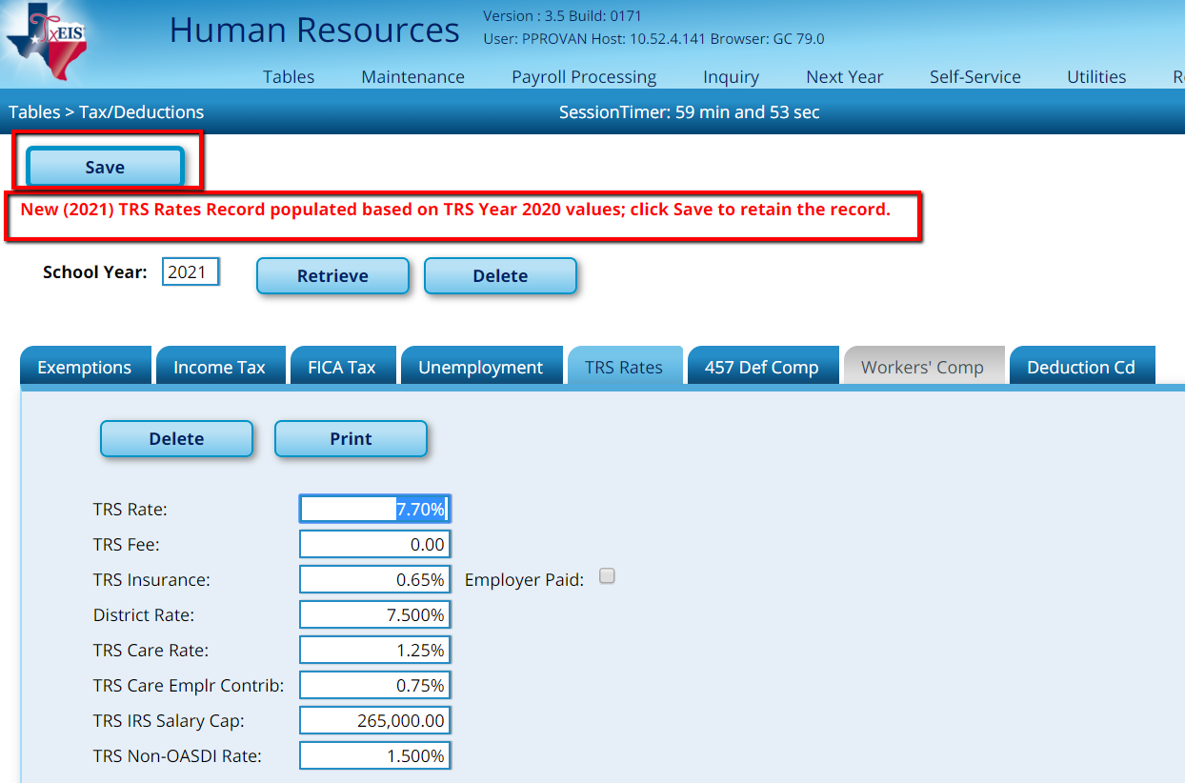

2021 TRS Contribution Rates will remain the same except for the Public Education Employer (Non-OASDI) Contribution, which will increase to 1.6%. You will want to manually change this and SAVE.

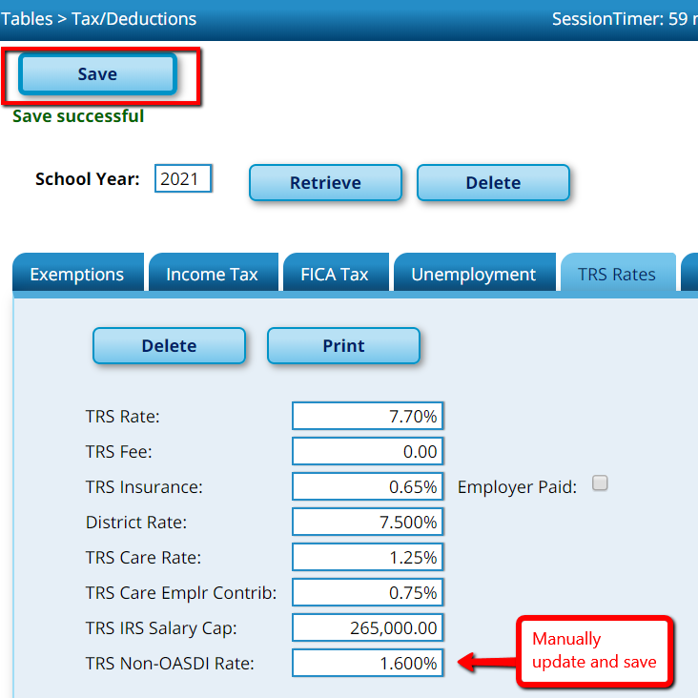

30. Update tables that use account codes such as Job Code and Extra Duty tables from Utilities > Mass Change Payroll Account Codes > Mask Crosswalk. Enter the From Fund/Yr and To Fund/Yr; select the Next Year Pay Frequencies and check the Options for updating the Job Code and/or Extra Duty tables. Execute.

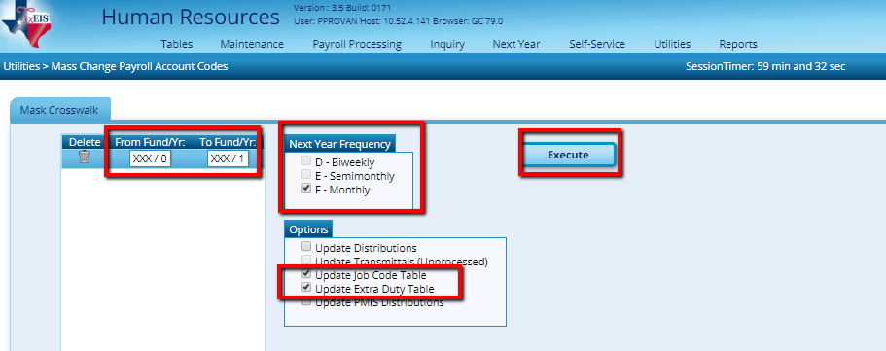

31. Review and update Extract IDs from Tables > Job /Contract > Extract ID tab.
Extract IDs are used to easily mass update employees with similar begin and end dates, payoff dates, etc… Review and update as needed.

Shown below are 2 examples of how you can enter the Extract ID and the Extract ID Description. You can enter the Code and Description that best suits your District.

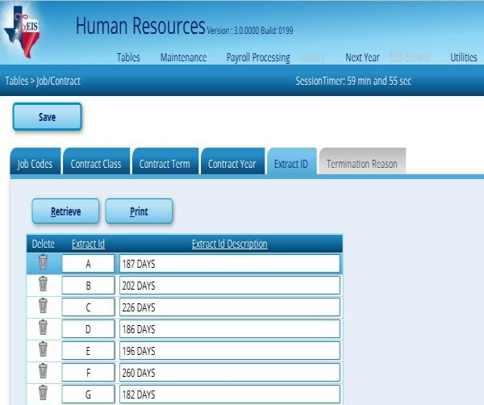
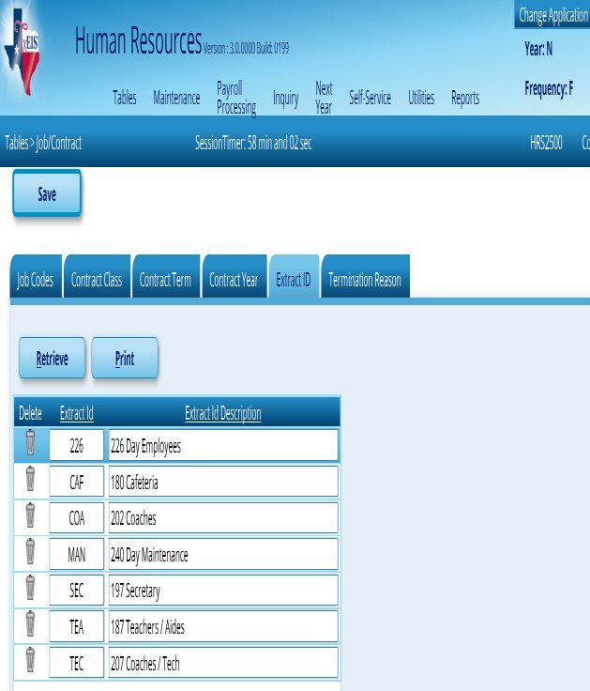

32. Ensure Extract IDs are correctly assigned to employees with a User Created Report. From Reports > User Created Reports > HR Reports, select the following criteria and Create the Report:
- Employee Number
- First Name
- Last Name
- Extract ID

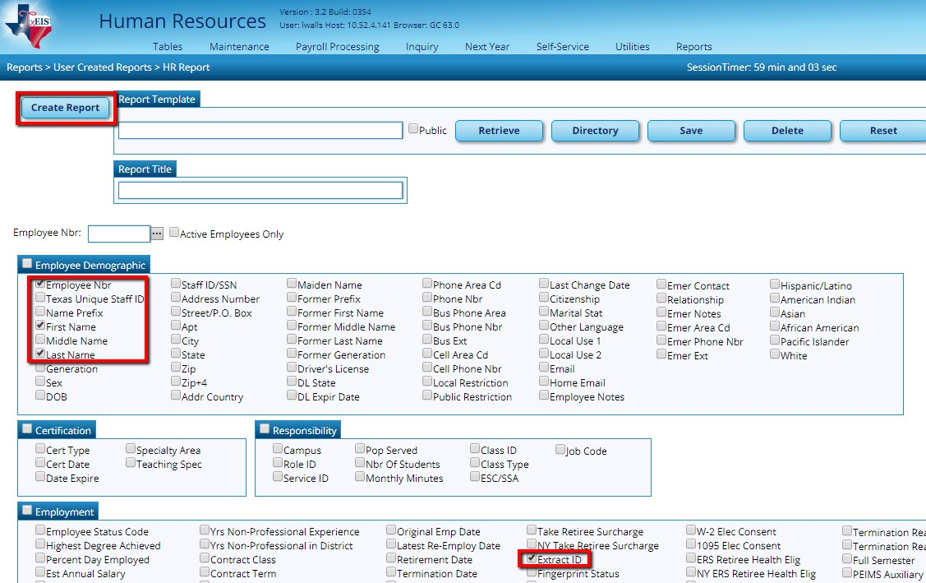

Review the report to ensure Extract IDs are assigned to applicable employees and that the IDs are accurate. You can sort by Extract ID.

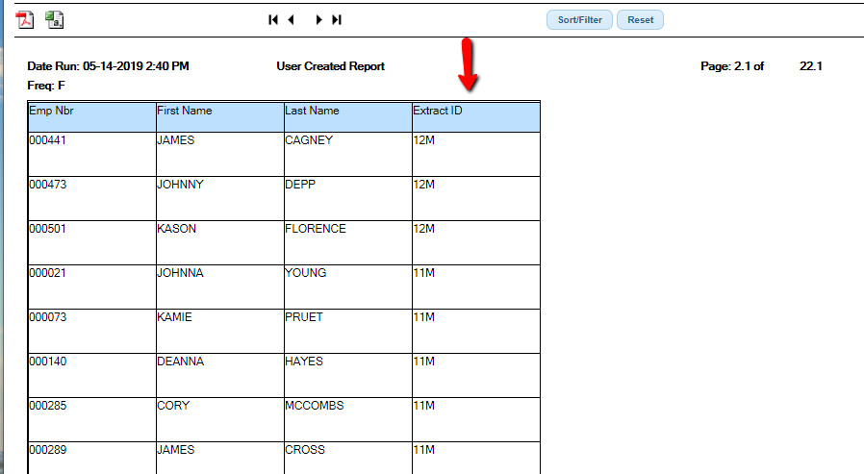

If Extract IDs need to be added or changed, make changes on the employee’s Employment Info screen. From Maintenance > Staff Job/Pay Data > Employment Info tab, select the applicable Extract ID and Save.

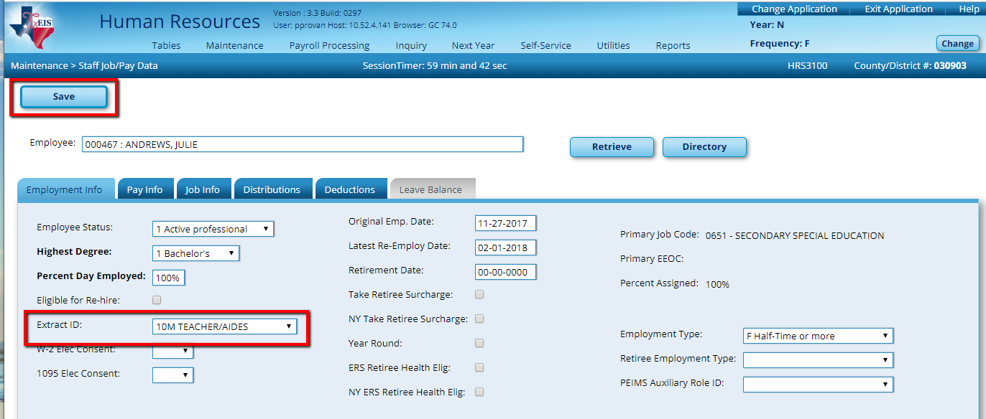

If you selected to update the new fiscal year in Step 27, then you can skip step 33.

33. Update the Fiscal Year code and all pay distributions. Utilities > Mass Update > Employee Tab. While on the mass update screen, de-select Pay and State Step Increment check boxes and check the Fiscal Year box. In the field to its right, enter a 1 for 2021.
Execute.

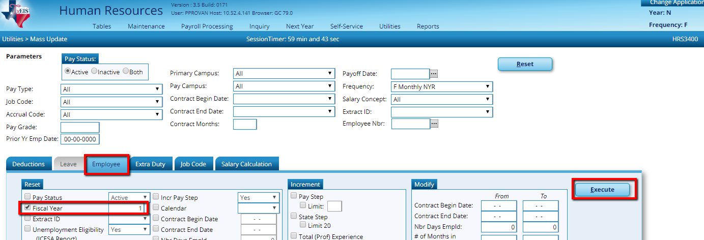
At the preview, select Process.

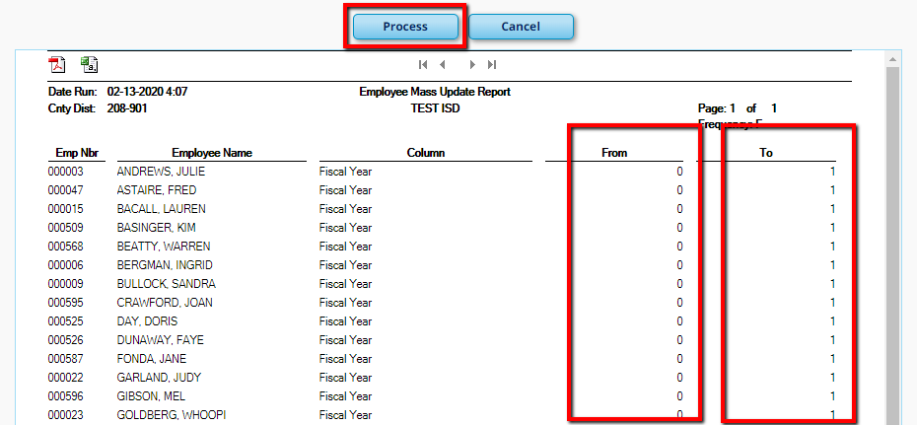

34. Increment Pay Step, State Step. From Utilities > Mass Update > Employee tab, update data for groups of employees.

Increment Pay Step and State Step: for all employees that have earned one year of experience for pay purposes.
NOTE: Be careful to complete this step only once on each employee as there is no way to ‘un-increment.’

In the Prior Yr Emp Date parameter, enter the date that represents the minimum number of days required for the employee to have earned a pay step advance (90 days prior to the end of their contract or the beginning of the second semester if the second semester is less than 90 days). The system will select all employees who were hired on or before that date. This will ensure that any employees hired after that date do not get incremented a pay step.

Note: If no date is displayed in an employee’s Latest Re-Employ Date or Original Emp Date field on the Employment Info tab, the employee will not be updated.

Check the Pay step and/or State Step boxes. If applicable, designate the Limit under Pay Step indicating the highest pay step within your local salary tables. All districts will check the box under State Step and Limit to 20 on applicable employees. The State step is used in the TRS State Minimum calculation and stops at 20 years of experience for that calculation. Some positions like the Superintendent will not get a Pay Step but all will get a State Step. Some positions like Teachers Aid, Bus Driver, Cafeteria workers will not get a State Step but may get a Pay Step. For this reason, we recommend completing this step by Pay Type or Extract ID to ensure the steps are updated correctly. For example, Pay Type 1 will update both Pay and State steps, however Stat Min is not calculated on Pay Type 2 employees, so only the Pay Step will be used on them.

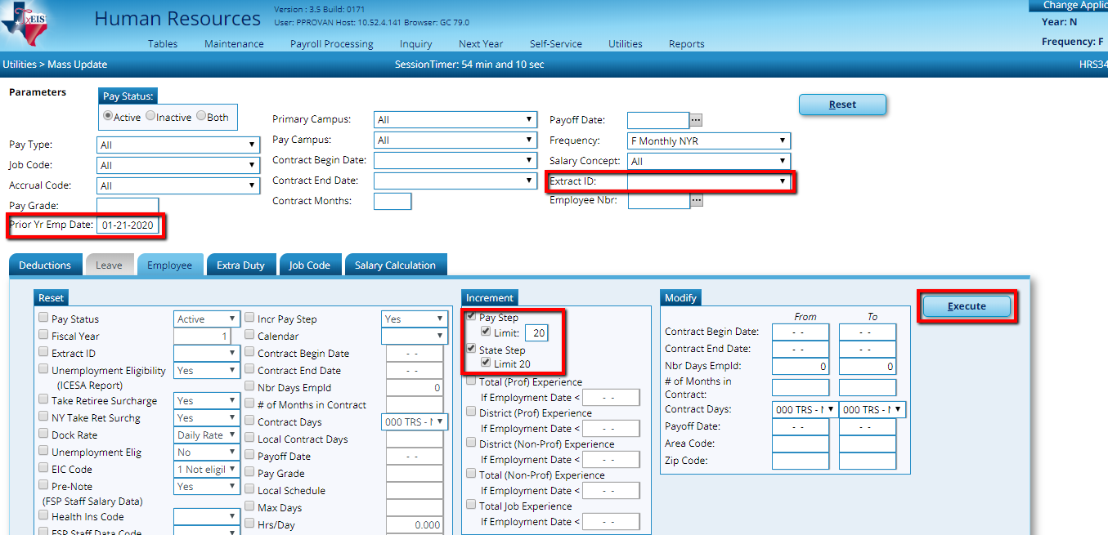
The prior year employment date is a sample. This will depend on the district’s calendar.

The next 5 Boxes below State Step will be completed after June Payroll when you do Service Records
Do this step by Pay Type or Extract ID’s to ensure steps are indicated accurately.

At the preview, select Process.

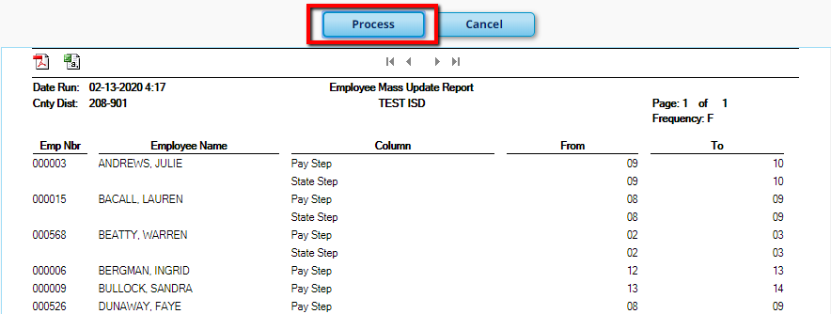

Repeat for each set of employees, changing options and the Prior Yr Employment Date, Pay Type and/or Extract ID as needed.

Note: We will not increment fields for Experience until after Service Records are processed. Instructions on incrementing Experience will be given in Part 3 of the Budget – First Payroll of the School Year.

35. Verify State Min info on all employees from Reports > User Created Reports > HR Reports.
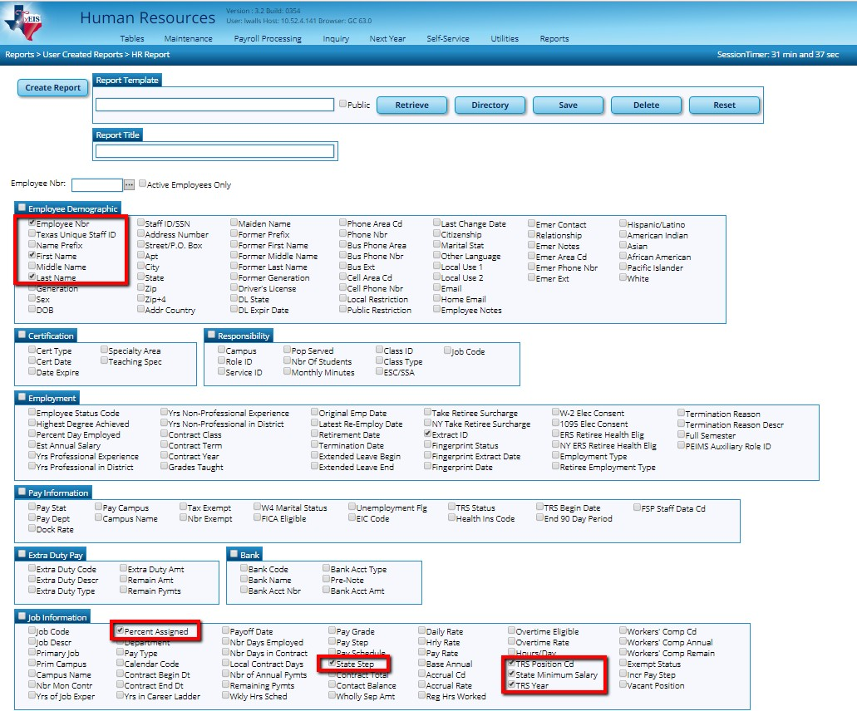

Verify the following:

  - TRS Position (01 = Professional; 02 = Teacher or Librarian; 03 = Support Staff; 04 = Bus Driver; 05 = Full-time Nurse or Counselor; 06 = Peace Officer)
  - State Step only displays on those with a Member Position of 01, 02, and 05
(must be 2 digits and not exceed 20)
  - Percent Assigned (if the employee has multiple jobs, ensure that the percent assigned adds up to the correct percentage in total.) 100% is reflected at 1.0; 50% as 0.5, etc…
  - TRS Year (should be turned on if the employee’s first payroll of their new contract is prior to September.)

State Minimum Salary

Source for ensuring employees are assigned to the correct Member Position Code is the TRS Payroll Manual in the Statutory Minimum Report section: http://www.trs.state.tx.us/traqs/documents/sm_statutory_minimum_report.pdf

36. Perform State Minimum Salary Calculations from Utilities > Mass
Update > Salary Calculations. This process will only calculate on employees with a TRS Member Code of 01, 02, or 05 and who have a two-digit State Step and Percent Assigned as verified in the previous step. In the Parameters area, select a Salary Concept, select A – Use annual salary table. On the Salary Calculations tab, select the State Minimum Only radio button and select whether to Apply Percent of Day Employed to Salary Amount. Execute.

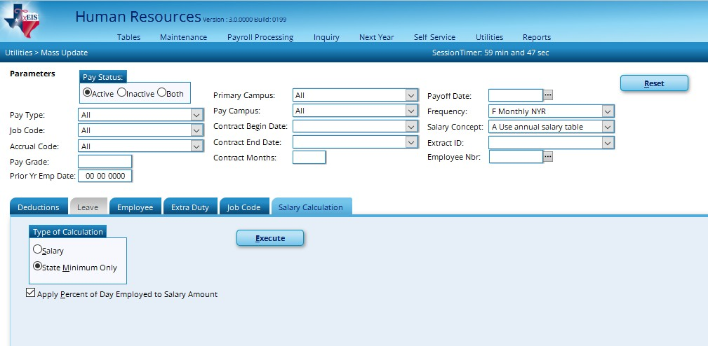

An Error Listing Preview displays. Employees listed on this preview will be excluded from State Minimum Calculations. It will be important to review the employee’s Job Info screen to see if any of the information required is missing or incorrectly represented. Common errors include:

    - State Step is missing or is only one digit (5 instead of 05)
    - State Step exceeds 20
    - Percent Assigned is missing or inaccurate (Contracted Instructional Staff, retirees and employees working less than half time should show 0 Percent Assigned as State Minimum is inapplicable to these employees.)

Once the Preview is clear or accurate, select Process.

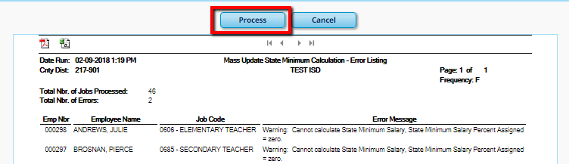

37. Mass Update Remaining Deduction Payments. From Maintenance > Staff Job/Pay Data. For deductions that don’t show 99 Payments (for continual deductions) in the Deduction screen of each employee (as shown below) you must update the payments now in order to budget correctly for those benefits.

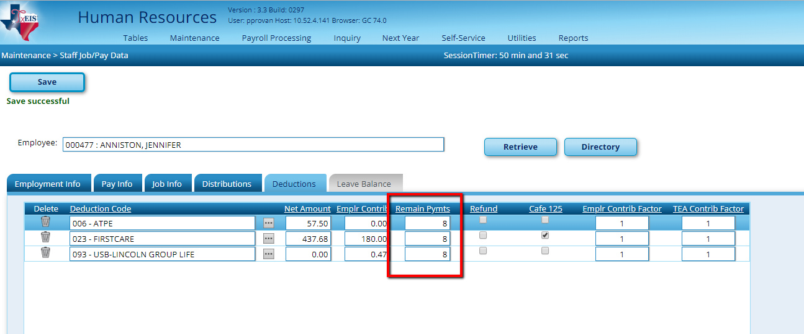

Note: We recommend using a User Created report to see the number of remaining payments that currently display in Employees’ deduction Screen. Select First Name and Last Name. Under the Deductions section select Deduction Cd and Remain Pymts.

From Utilities > Mass Update > Deductions tab, select the Method to Change Remaining Deduction Payments. Select the appropriate Deduction Code and Remaining Payments. Execute. Repeat as needed.

Example: The Employee’s Deduction screen shows 6 pmts left for TSTA. The employee usually pays over 10 months. Choose the radio button for Change Remaining Deduction Payments. Select Deductions 005 –TSTA DUES and enter 10 Remaining Payments. Click Execute.

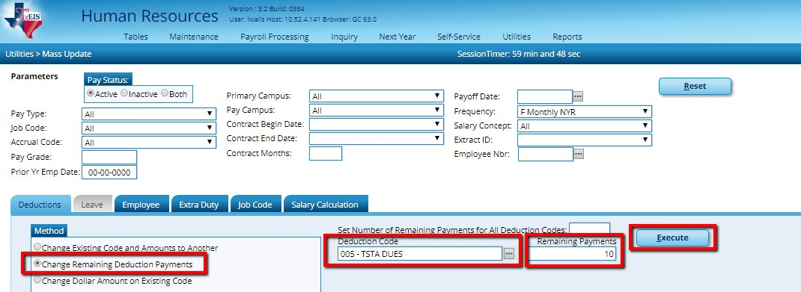

Select Process at the Preview.

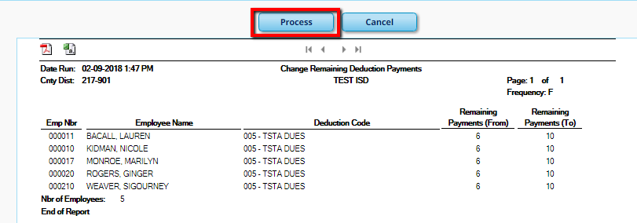

38. Add new employees and/or vacant positions, and update existing employees who were not updated during the previous steps through Mass Update. Keep the following in mind as you update:

Maintenance > Staff Demo and Maintenance > Staff Job/Pay Data
Employment Info are shared with Current Year Payroll.

  - Maintenance > Staff Job/Pay Data Pay Info, Job Info, Distributions, and Deductions are not shared with Current Year Payroll.

  - The exception to these are those areas where you are asked whether you want to change Current Year information as well as Bank Info, W-4 status, exemptions, etc…

39. Review NY TRS Retiree Surcharge flag and TRS Care Employer Surcharge Amounts on applicable employees. This is most easily done through a User Created Report.

Reminders:
  - Retiree (Pension) Surcharges apply to regular retirees who retired after Sept 1, 2005 and all disability retirees who are working in a TRS eligible position
(half-time or more). Bus drivers are not necessarily exempt from surcharges.

  - (Pension) Surcharges are not due on retirees working as subs, less than half- time, or who retired before Sept 1, 2005

  - Based on known rates, the Pension Surcharge Rate for 2020-2021 is 15.2%.

  - Consult the TRS/TEAM website to determine if the TRS Care Surcharge is due on a retiree. If it is, add to their deduction screen. The amount will be
$535.00 in the Employer Contribution Column.

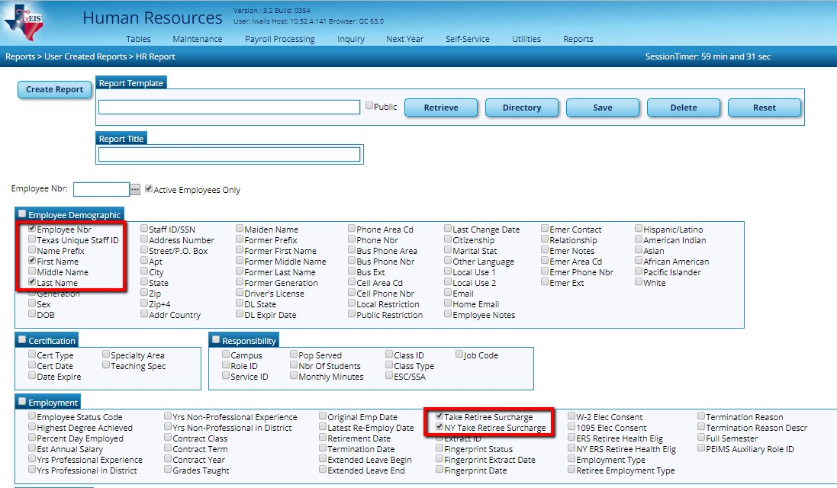

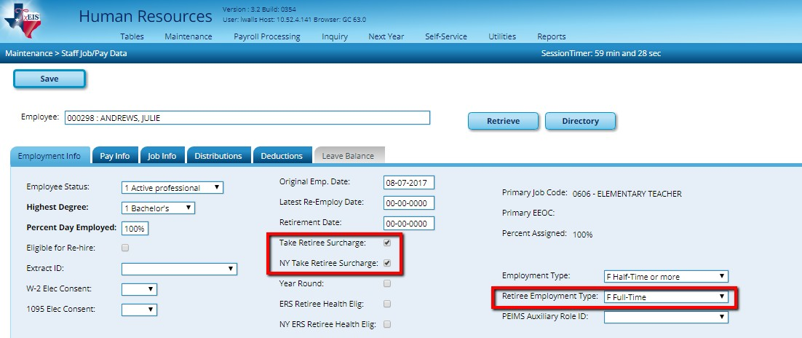

40. Perform Salary Calculations for Employees tied to Salary Tables. From Utilities
> Mass Update > Salary Calculation tab, select a Salary Concept in the parameters. Select the radio button for Salary and check to Apply Percent of Day Employed to Salary Amount. Execute.

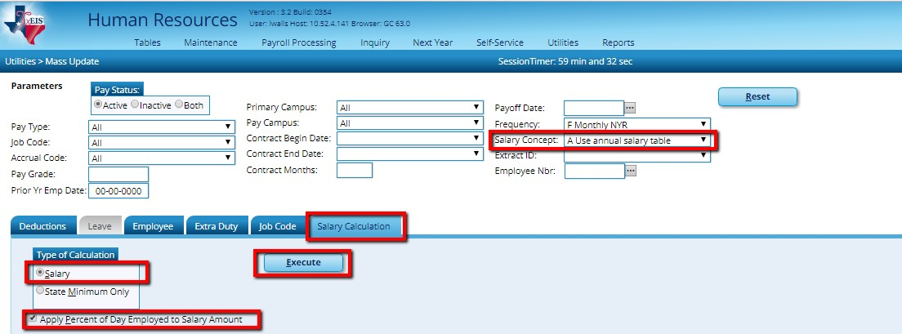

An Error Listing will display like a preview. Any employee listed on the Error Listing will not update. Ensure that those listed are employees who should not be tied to a salary table. If employees are listed who should be tied to a salary table, review the error message to determine the issue. We recommend you cancel and fix any unwanted errors before proceeding. Once Error Listing is as you wish, Process.

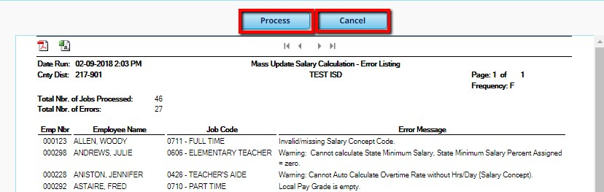

41. Compare NY Salary to Current Year Salary for Pay Type 1 & 2 employees from Reports > HR Reports > Payroll Information Reports > HRS 6650 (CYR/NYR Salary Comparison.) This report will allow you to see changes by individual, but will also provide a Fund Total Report that can be very helpful with Budget.

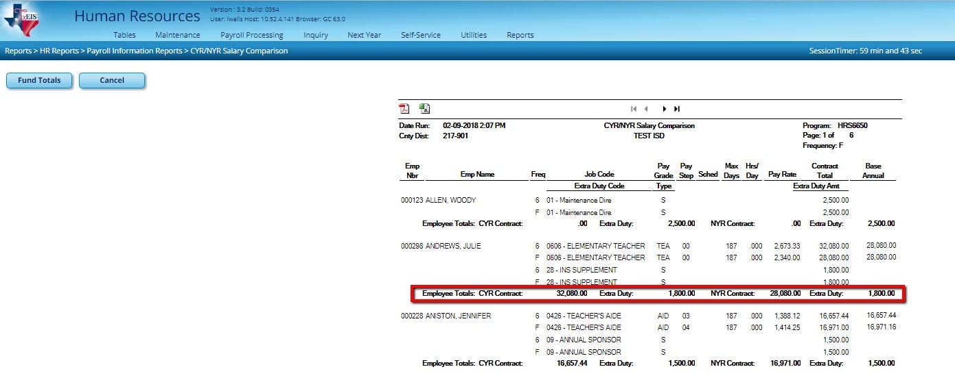

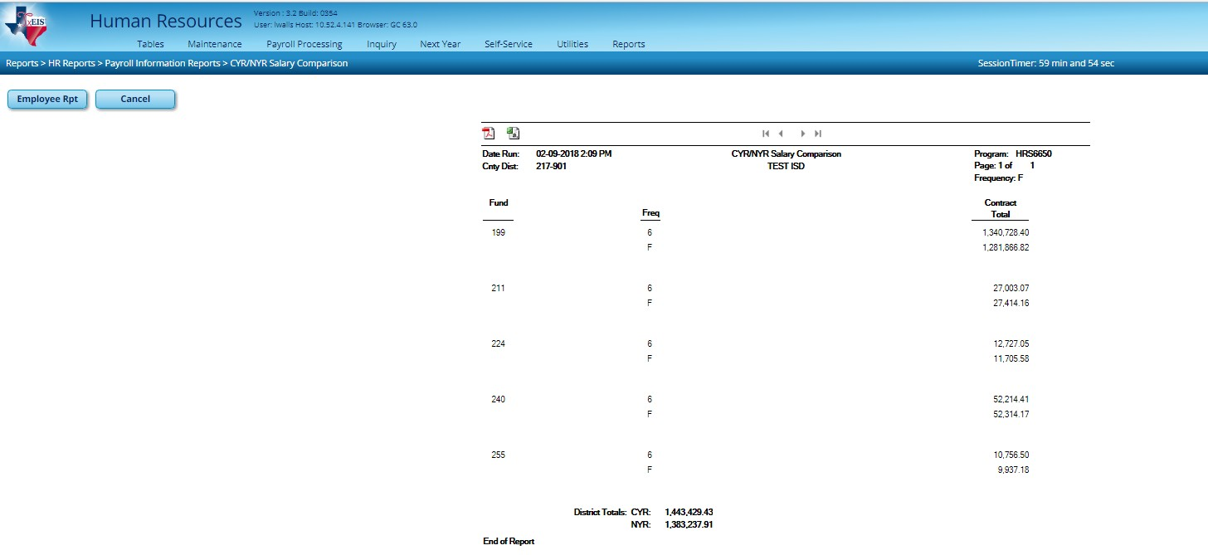

42. Extract Next Year Payroll Information to Budget. From Next Year > Interface NY Payroll to NY Budget > Extract Payroll Account Codes tab, enter your TRS On Behalf Expenditure Account, enter the Starting Accounting Period for the Finance Fiscal Year, and move all employees to the right and Run.
This should match the account parameters used when generating the TRS On-Behalf Journal during payroll
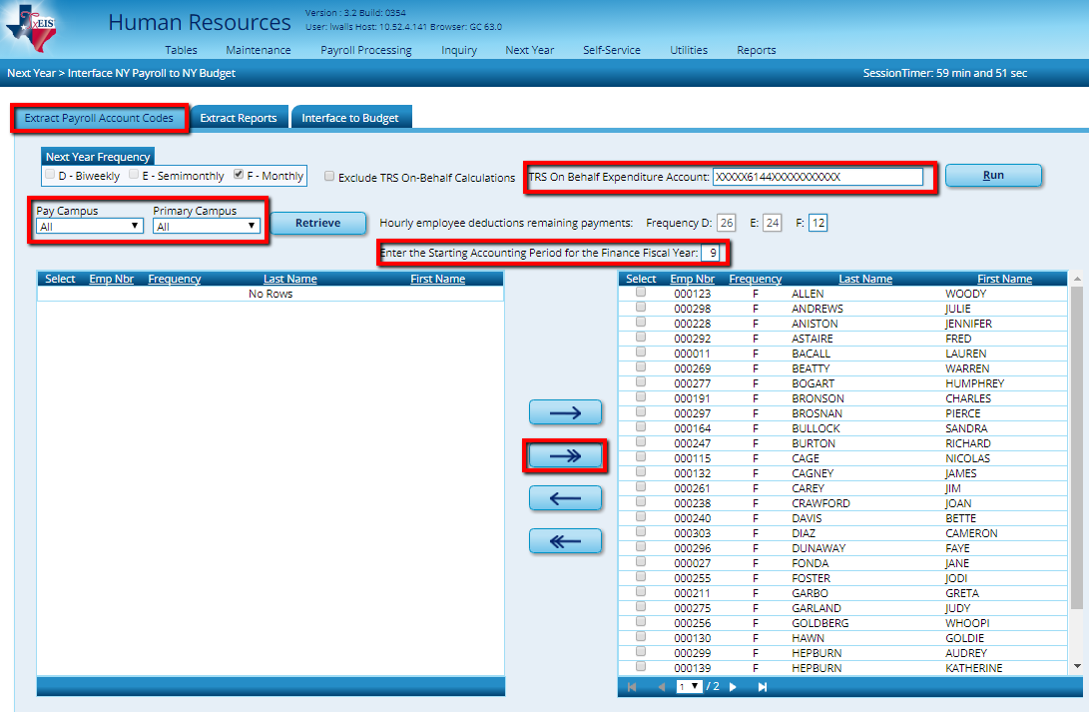

Consider the following:

  - Employees who are ‘Inactive’ in Next Year Payroll will not be counted in Budget totals

  - Amounts budgeted for employer contributions for deductions, such as health insurance, will equal amount in deduction screen remaining payments. If using 99 payments, the system will budget the amount times remaining payments for the contract.

  - Fiscal Year in all employee distributions must be accurate to match with existing Account Codes in Budget. If accounts do not match, an error message will be displayed indicating that the account in HR distributions does not pass validation. You must then either add it to Budget or change it in HR.

  - Once you have extracted and interfaced, amounts will only be overlaid with new figures when account codes match exactly. Therefore, careful consideration should be made to the TRS On Behalf Expenditure Account so that On Behalf is not ‘double-budgeted’ on a subsequent extract and interface. Be sure to use this account code in your Payroll process throughout the year (Payroll Checklist step 44.)

  - This process can be repeated as often as needed but each time you make changes you must extract the employee account codes again.

At the Preview, review your Failure and Warning Messages. Employees with a Failure will not process at all. Those with Warnings will process, but may not include all the amounts you desire. You may only Close this report. If there are corrections that need to be made, you can do so at this point. If not, proceed to the next step.
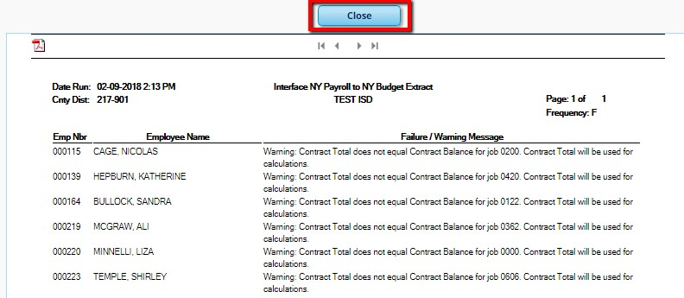

43. Once extracted, proceed to the Extract Reports tab. Verify both Extract Reports for accuracy.
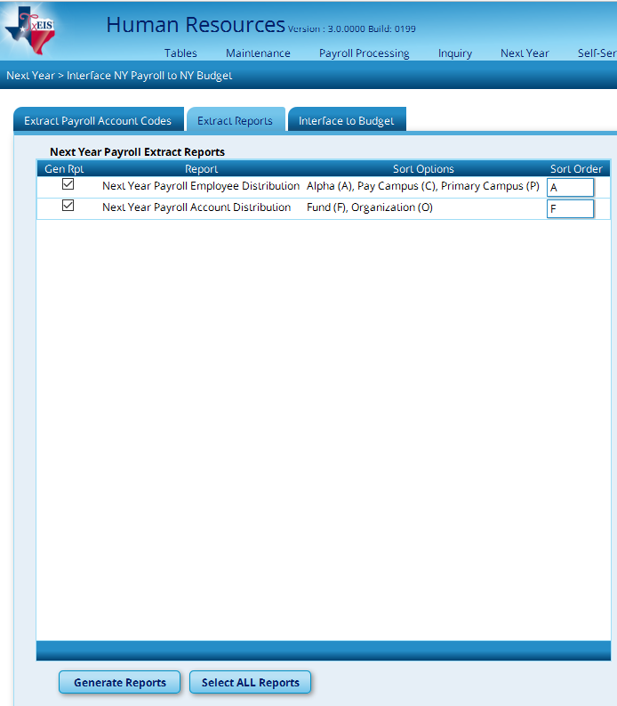

Consider the following:
    - All new employees and/or vacant positions are represented.
    - All employees needed for budget are on the report.
    - Grant Codes, Accrual Codes, and Account Codes are accurate.

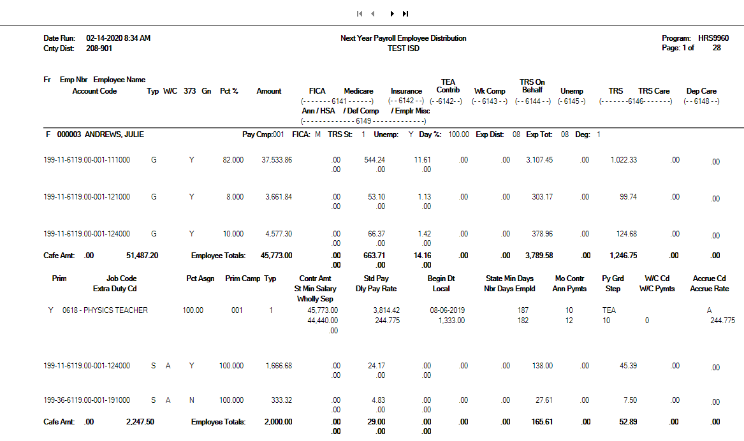

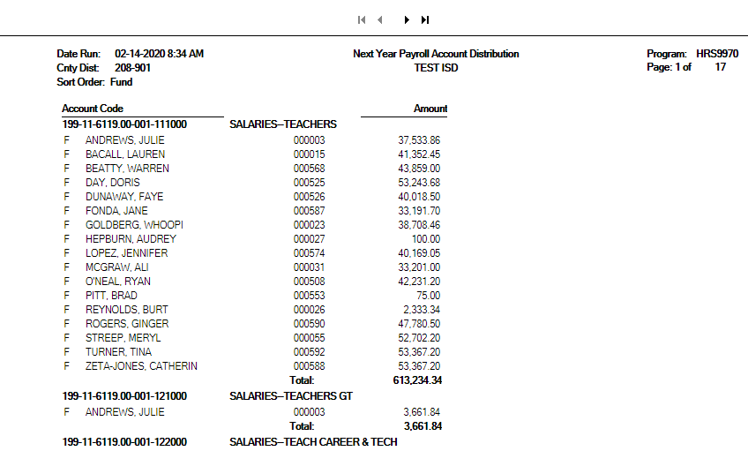

After reviewing reports, make any necessary corrections, re-extract, and re-verify until data is accurate. This can be repeated as often as necessary.

44. Interface NY Payroll amounts to Budget from Next Year Payroll > Interface NY Payroll to NY Budget > Interface to Budget.

Note 1: When the Requested column is selected for interfacing, the payroll accounts (61XX accounts) only display on inquiry or in reports. The Requested column does not display the 61XX accounts on the maintenance screens.

Note 2: The interface to Budget process over-writes existing data as long as the accounts match. Keep in mind for all subsequent interfaces that if there is not a match, the original accounts, that may no longer be needed, will not be deleted. Example: If you originally budgeted for only one RN coded to 199-33-6119… then did not hire this position and hired an LVN instead that uses 199-33-6129… then both accounts will be in budget. The amounts originally budgeted in 199-33-6119 (and the corresponding benefit accounts) will need to be deleted or adjusted manually in Budget.

Select the Budget tab you wish to see the amounts interfaced to. Select the box to Round account totals to the nearest dollar and select Interface.
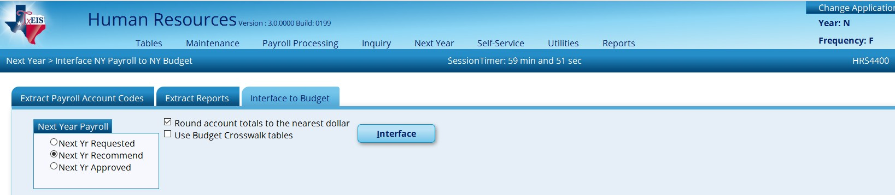

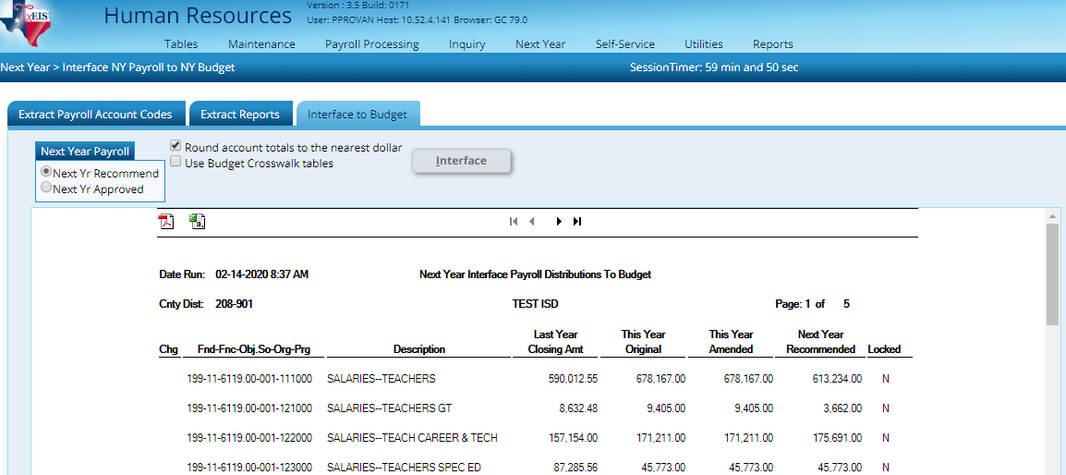

45. Create Employee Benefit file for your Third - Party Administrator (TPA) and email to them. From Utilities > Employee Benefits Interface > Extract tab, select Current Year and Execute.
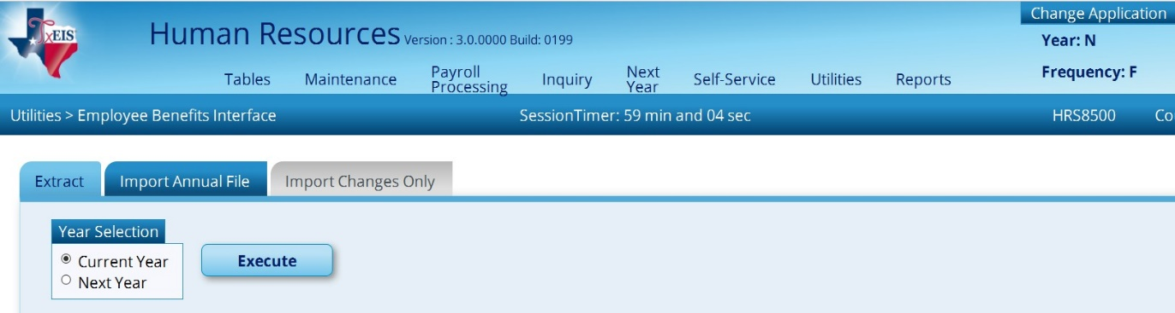

If you have employees with duplicate deduction codes in their deduction screen, a report is displayed with that information. Click Continue. At the Employee Benefits Interface Extract preview, click Process. Two files will be created. One contains demographic information; the other will contain current deduction records. Save both files and forward both to your TPA.

